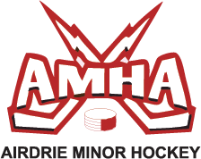
COACHING CLINICS and COURSES REIMBURSEMENT REQUEST
(this form must be submitted with copy of receipt)

NAME: _______________________________________________
MAILING ADDRESS:______________________________________________
TEAM COACHING: ______________________________________
(circle one) HEAD COACH ASSISTANT COACH
CHILD’S FULL NAME: ____________________________________
COURSE(S) TAKEN: ______________________________________
COURSE DATE(s):____________________________________
REIMBURSEMENT REQUEST TOTAL: $_______________________

Signature:_____________________
By signing this form you confirm that you have taken the courses and completed the requirements for certification.

Please forward this completed for with a copy of the paid receipt to amhacoachingreceipts@gmail.com
DEADLINE TO SUBMIT 2014/2015 coaching receipts is January 7th, 2015. NO CHEQUES WILL BE ISSUED AFTER THAT DATE

