Pincher Creek Curling Club Combo Bonspiel 2019
Mens and Ladies Teams

January 11, 12 & 13
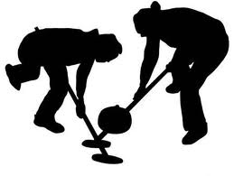
$220.00 per team

Cash Prizes,
$20 Calcutta,
Entertainment,
Prime Rib Supper

Novice or Experienced – Single or Teams – Call and Register!
Teams Contact: Jessie Nelson 403-627-8303

Pincher Creek Curling Club Town and Country Bonspiel 2019

Any combination teams accepted / 4 events!

February 4, 5, 6, 7, 8 & 9
Weekdays are evening curling only

$180.00 per team

Tons of Prizes and Prime Rib Supper

Represent your place of business or non-profit group with a curling team!

Register as a family curling team

Novice or Experienced – Single or Teams – Call and Register!
Contact: Bryan 403-627-2643
Pincher Creek Curling Club Sturling Stake Bonspiels 2018/19
Two people per team- any combination
November 24, 2018 &
March 16, 2019

$50.00 entry fee

Cash Prizes,
Guaranteed 3 games
Novice or Experienced– Call and Register!
Teams Contact: Garry Cleland 403-339-5040

