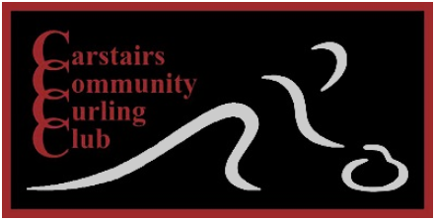
Carstairs Mixed Doubles Bonspiel
January 11th – 13th, 2019
Entry Fee = $100 per Team (one male / one female) includes Saturday lunch
Cash Payout
Guaranteed 3 Games
For more information or to sign up, contact:
Kerry Meyers @ 403-831-4190 meyers.kerry@gmail.com
Chelsie Meyers @ 403-835-4191 chelsie.meyers@gmail.com

