KEVIN MARTIN
ACADEMY
SEATTLE Nov. 1 & 2, 2018
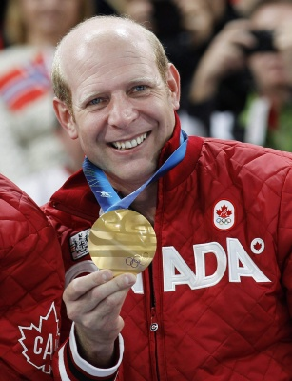
Learn to throw like Kevin Martin

-All ages and skill levels
-Four pillars of the delivery with Kevin Martin keys for each:
Set Up
Drive
Slide
Release
-Classes are 2 hours. All on-ice, small class sizes so individual attention
-Customized instruction for your delivery
-Class ends with sweeping

Top players in the world come to Kevin every year for guidance.
He will change your game

SIGN UP at: www.letscurelupus.org

Price is $125 per adult and $100 for persons age 21 and under

