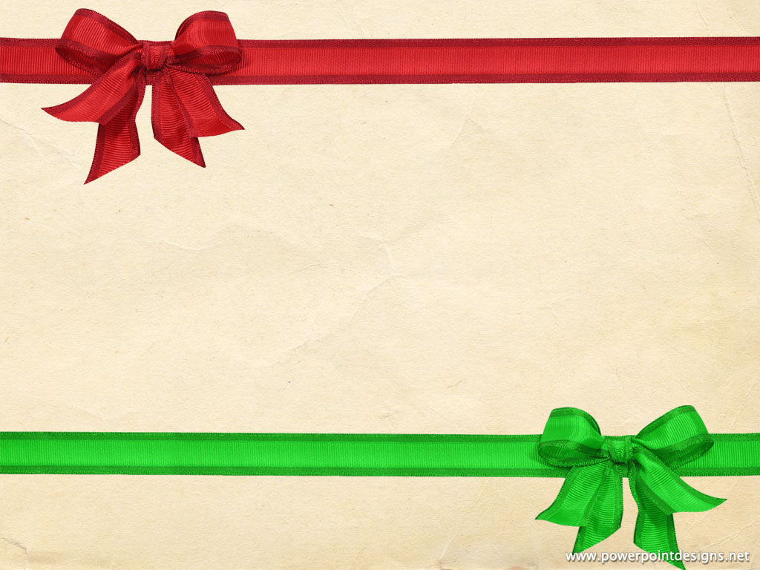
Join us for this year’s
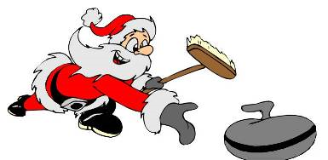
NOEL SPIEL
at
HUNTINGTON HILLS COMMUNITY ASSOCIATION
December 8, 2018
8am -4pm
This is a Novice FUN Spiel
Cost is $100 per team
Lunch is provided for all participating curlers.
To register contact Barb at
587-392-2264 or at barb.d@huntingtonhillscalgary.com

