HUNTINGTON HILLS CURLING CLUB
520 – 78 Ave NW, Calgary

November 2-4, 2018

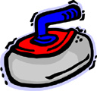

$240 Per Team
3 events
Saturday Banquet
Theme: Rock Stars
To Register: Contact Marg @ 403-540-6383 or e-mail marg61matthews@shaw.ca
Entry Deadline: October 29, 2018

