Hockey Equipment Requirements

- Hockey Helmet with mask (must be CSA approved)
- Hockey Skates (no figure skates allowed)
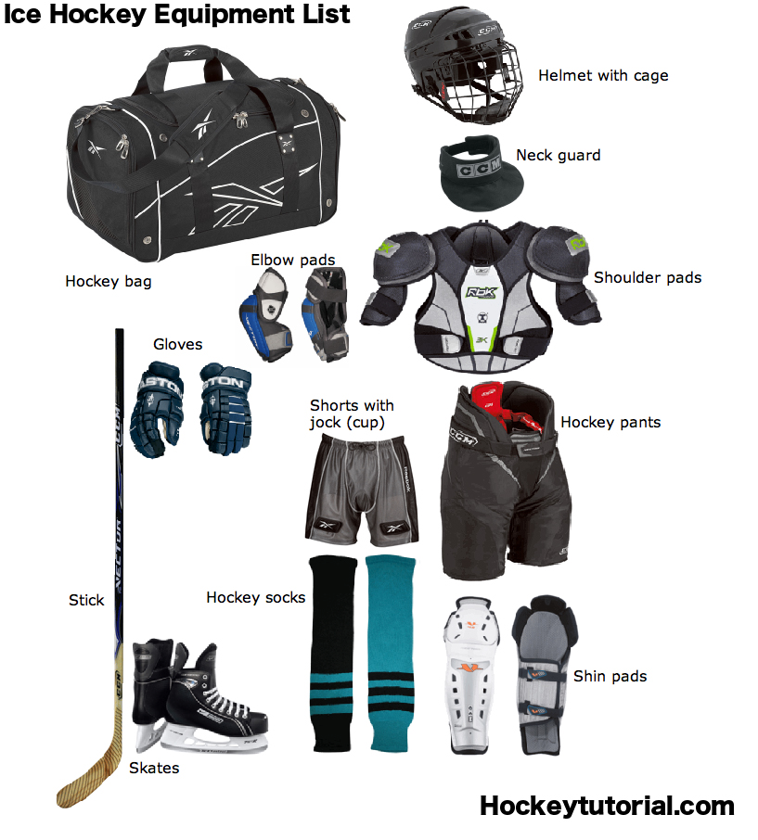
- Hockey stick, taped at both ends. Cut the stick to between chin and nose length.
- Neck Protector
- Shoulder Pads
- Elbow Pads
- Hockey Pants
- Hockey Gloves
- Hockey Socks
- Shin Pads
- Protective cup or Jill Strap
- Hockey Bag
- Water Bottle
- Mouth Guard (optional)
- Practice Socks
- Practice Jersey

Game jerseys and game socks will be provided by BMHA.
Items can be purchased new or used.
Please remember that your child’s safety is due, in part, to the equipment they are wearing.

