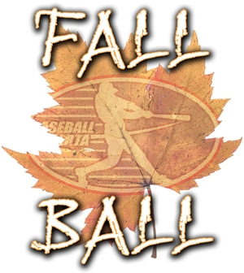
2018 Fall Ball Development Team Entry Form
Deadline for Entry August 28, 2018

TEAM INFORMATION
Association Name:
Team Name:
Division:
Mosquito | Pee Wee | Bantam | Midget

TEAM CONTACT INFORMATION
Head Coach
Name:
Primary Phone Number : Secondary Phone Number:
Email (mandatory):
Off Field Manager/Team Contact
Name:
Primary Phone Number: Secondary Phone Number:
Email (mandatory):

DIAMOND AVAILABILITY
(Select all weekends that your diamond is available to host games)
League Dates Diamond Information
September 8th Yes No Ball Park Name
September 15th Yes No
September 22nd Yes No Ball Park Address
September 29th Yes No

UNIFORMS
As this is a Developmental League, we recognize that a relaxed uniform standard is necessary. The uniforms must be of the same dominant colour. The game pants, undershirt sleeves and hats are not required to be of matching colour.

UMPIRES
The $400.00 Team Fee paid for by all teams is used to provide payment of all umpire game fees for Fall Ball games. Baseball Alberta will schedule and pay all umpires during the Fall Ball schedule.

TEAM FEES
Fee Type Fee Amount Fee Paid
Fall Ball ‘D’ League Team Fee $400.00 $400.00
Player Fee (Only for players who were not registered with Baseball Alberta in 2018)
Number of Players
Fees per Player $10.00 =
TOTAL TEAM FEES OWED =

All completed forms must be submitted to Baseball Alberta by August 25th, 2018

Forms can be sent by:
Mail  Baseball Alberta  11759 Groat Road  Edmonton, Alberta T5M 3K6 | Email  programs@baseballalberta.com

