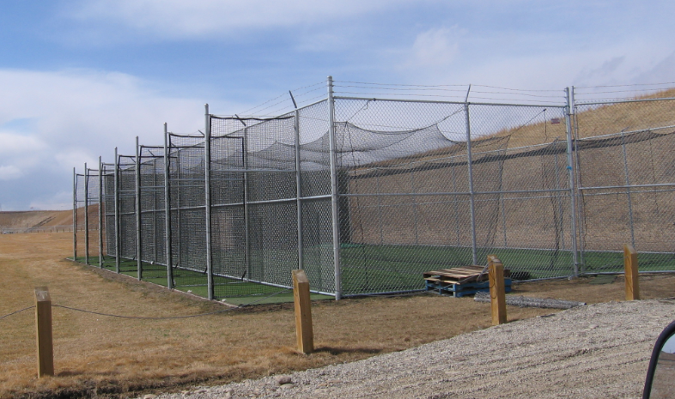

- Absolutely NO spikes, spits, chew, gum: respect the turf!
- Do NOT EVER bat hard balls against any chain link!
- Leave the cage and area around the cages cleaner than when you got there … yes we know it’s not your garbage!
- Ensure all equipment is put away neatly in Ccan
- Always extend an open invitation to the opposing team to use the batting cages before and between games; please ensure the other teams abide by the rules.
- Ensure all gates are closed and locked when leaving.

