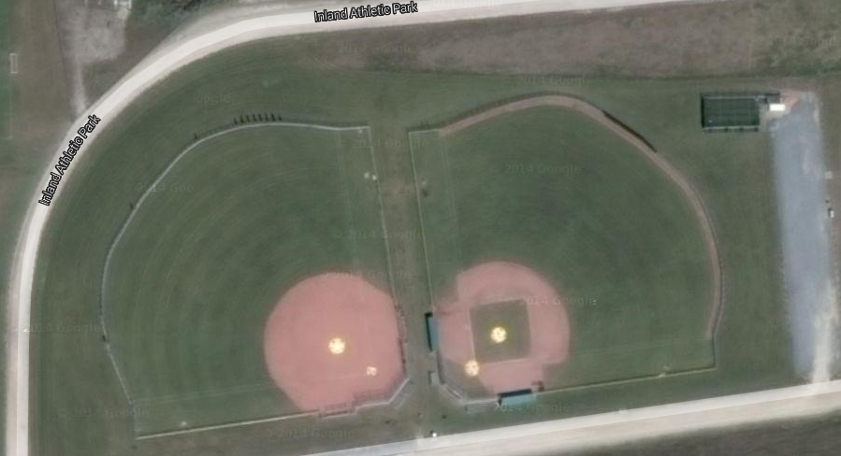

EVERY DAY leave the diamond(s) in better condition than when you started;
- empty garbages,
- pick up litter (of course it’s not your litter)
- pick up recyclables from inside dugouts, as well as inside and outside the diamond.
- Tarp mounds, batters’ boxes, bullpen mounds.
- Put bases away, organize and stow hitting screens inside dugouts, put away hoses.
- Ensure all gates and equipment boxes are locked!
- Sweep shale off of grass and back onto shale.
- Fix mound and batters’ boxes every time.
- Be proud of INLAND and be proud of how you keep it!

