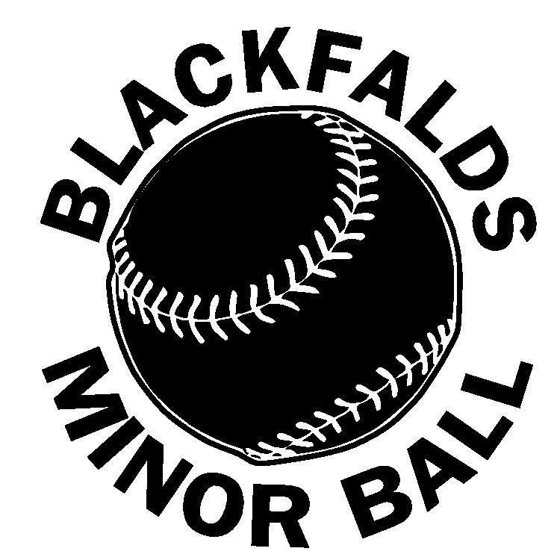
Blackfalds Minor Ball Girls Fastball Registration Form
Pirates Girls Fastball 2018 Season

Please circle the division you are registering for:

Divisions:
U8 – Born 2010 or later $100.00
U10 - Born 2008, 2009 $100.00
U12– Born 2006, 2007 $125.00

**After February 20th, fees increase by $50.00**
** We will be asking players to participate in a $100.00 fundraiser.**

Has your child played organized softball: YES NO Years played:_______

Player Name:_______________________________ Date of Birth: _____/_____/_____

Mailing Address:__________________________________Postal Code:_________________

Phone: Home:______________________________ Cell:_________________________

Name of Parents/Guardians:_________________________________________________

Email Address #1:_________________________________________________________

Email Address #2:_________________________________________________________

Residential Address:__________________________________________________________

Does your child have any medical /health issues? (Please specify)___________________

Alberta Health Care #:______________________________________________________

Are you able to volunteer?? Please circle all positions you would consider.

Team Manager Coach Diamond Set Up

I do hereby waive and release all rights and claims for damages I may have against Blackfalds Minor Ball, its instructors, Coaches and Umpires or Administrators, for all injuries which may occur to myself, my child/children while participation in Blackfalds Minor Ball programs.

_________________________________ _____________________________________
Parent/Guardian Signature Date

I, _________________________________ (guardian) hereby give my consent to allow pictures of my child

_____________________________ to be displayed as part of our associations promotions. Eg. Website, Facebook, local paper.

__________________________________ _______________________________________
Parent/Guardian Signature Date

What equipment will a player need for Girls Fastball?

All players will need good running shoes or cleats, ball glove and the following equipment.

Safety is very important to us.

The following safety equipment is required:

All Blackfalds Girls Fastball players are required to have and wear a batting helmet.
- These helmets must have a cage and attached chinstrap.
- Players must always wear this protection.
- Games, practices and while running the bases.
- Bat boy/girls both on the field and in the dugout.

- Pitchers will be required to wear a pitching mask. These will not be supplied by the association as they are a personal item.

- Catchers are required to wear a personal protective cup (Jill). It is recommended that pitchers wear one as well.

- It is recommended that all players in the infield were a protective face mask in the interest in player safety.

- All girls are required to have and wear a batting helmet with a chinstrap and facemask. Batting helmets will not be provided by Blackfalds Minor Ball.
  - Batting helmets will need to be worn when batting and running the bases.

Blackfalds minor ball will supply some bats for the teams, but players are welcome to bring their own. Catching equipment and bases will be supplied by Blackfalds Minor Ball.

How to contact us:

Pirates Fastball Directors:
Stacey Smith (403)350-4321
Leslie Esteves (403) 505-9638
Facebook: Blackfalds Fastball
Twitter: @bfaldsfastball
Instagram: blackfaldsfastball
Email: blackfaldsfastball@gmail.com

