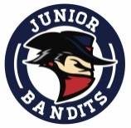
Brooks Minor Hockey Association
Amendment to Bylaws Form

2017 ANNUAL GENERAL MEETING
NOTICE OF MOTION #:__________________________

AMENDMENT TO BYLAWS

BYLAW #: _________________ PAGE #: _________________
SUBMITTED BY: ____________________________
AUTHORIZED BY: ____________________________

CURRENT WORDING:

PROPOSED WORDING:

RATIONALE FOR CHANGE:

