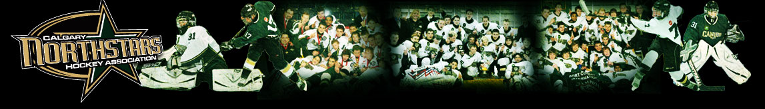

2018– 2019 CNHA YEARBOOK REQUIREMENTS

- Each required player commitment level →$500.00
  - Through advertising sales or family may choose to pay commitment in cash
  - GST not calculated in the commitment totals if chosen to be paid out
  - GST is calculated on all advertisements (including family advertising)
  - GST is not included in the calculation of the 70% overage reimbursable amount

- Sales over commitment level → 70% back to player (family)
  - 70% overage may be used for:
    - Clothing
    - Team Fees (e.g. tournament fees)
    - Team registration

- Advertising monies/overages cannot be reimbursed at year end if not used (AGLC ruling)

- All ads must be handed into team Yearbook Coordinator by no later than October 31, 2018. See other side for acceptable ad formats.
Any questions or concerns should be directed to your team Yearbook Coordinator.

PDF files are the best way to submit ads to the Yearbook. PDF files are cross-platform compatible. Be sure to embed fonts and convert using maximum-quality, press-optimized settings.

Preferred Applications:
- PDF’s created from InDesign
- High Resolution Tiff or jpg files (Must be 600 dpi at 100%)

Removable Media:
- Compact Disc (CD/DVD)
- Flash Drives

Electronic File Submission:
Email to your team Yearbook Coordinator.
- Include in the subject line, the name of the advertiser and the word YEARBOOK
- Files submitted via email attachment should not exceed 10 megabytes
- Due to security reasons we are unable to provide an FTP hosting site
- Files example labelling: (lastname=players last name)

  - BC BW – Cedarglen Home –lastname.pdf
- Quarter pg BW – Cedarglen Home – lastname.pdf
  - Half pg BW – Cedarglen Home – lastname.pdf
  - Half pg CLR – Cedarglen Home – lastname.pdf
  - Full pg BW – Cedarglen Home – lastname.pdf

Applications NOT Accepted:
- Microsoft Word, Powerpoint, Excel, Quark.

Ad Sizes:
- Full Page: 7.125” wide x 10.375” deep
- Half Page: 7.125” wide x 5.125” deep
- Quarter Page: 3.5” wide x 5.125” deep
- Business Card: 3.5” wide x 2” deep

Tips:
- Colour ads are available on the inside front, back covers and throughout the book. These ads should be built in CMYK.
- Create solid black using 100% black; do not use Registration colour
- If working in Illustrator, convert all type to outlines before submitting ad
- Ensure all images have a resolution that is a minimum of 300 dpi (at 100% size)
- Scanned logos need a minimum resolution of 600 dpi (at 100% size)

