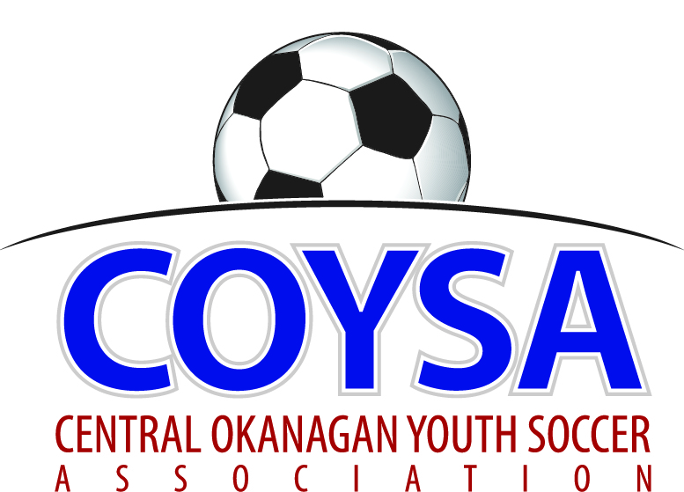
CENTRAL OKANAGAN YOUTH SOCCER ASSOCIATION
District Board Meeting: Wednesday, April 12, 2017 7:00pm
COYSA Boardroom, Kelowna, BC

MINUTES
APPROVED (as is/as amended): May 11, 2017 Motion #990
CALL TO ORDER: Roll Call
Dan Tauber, COYSA Vice Chairman, called the meeting to order at 7:08pm NO QUORUM to start
Present: Curtis Morcom (Treasurer), Sheryl Turner (Administrator)
Voting Members Present:
Adil Rajwani
Carrie Smith
Chad Cormack
Dan Tauber
Oliver Anstice
Rob Hopkinson
Scott Percival
Total Votes = 7
Regrets: Mike Jilek, Randall Wight, Bruce Clark (Discipline), Scott Jacobsen (Past Chair), Al Ryder (RiC/Ref Sch)
Absent: Jason Freh, Kelly Sherman, Surinder Gosal

PRESENTATION OF AGENDA - We can go over reports and have discussion, but no business until we have a quorum.
CHAIRMAN REPORT – written report.
TREASURER REPORT – written report. Discussion on gaming grants.
Curtis left at 7:18pm
REFEREE-IN-CHIEF / REFEREE SCHEDULER REPORT – written report.
DISCIPLINE COMMITTEE REPORT – written report.
ADMINISTRATOR REPORT – written report. Coaching courses, only 4 spots left in one, the other two filled. Administrator to ask how many still need courses. KYSA, WYSA, RYSA all subsidize coaches. Was asked by City to move drills around to different areas of the field to spread the wear around. Email went to Clubs.
Will arrived at 7:25pm
CLUB REPORTS:
KUFC – written report.
KYSA – written report.
LCYSA – written report.
OMYSA – written report.
Adil arrived at 7:50pm We have a QUORUM.
Want feedback if there is a desire to add U5s. Q: What is happening with Soccaskool? A: They are working with OMYSA, not sure what the direction is. They are talking. Not sure an agreement will be able to be reached. Difficult to come up with a solution. Everyone has concerns. Want to police it, bring it in, otherwise we have no control. Lots of misinformation out there. Hard to change the status quo. We can have some guidelines. They are market driven, they want to practice year round, lots of games, way beyond LTPD. They would have to adapt to fit in and there’s a lot we can do to restrict. Outside of COYSA there is Whitecaps and Soccaskool. Whitecaps are not running a league or creating teams. Running a team and playing games is different than coaching skills. Academy fills a void or niche that is needed but Soccaskool is doing more than BCSA wants. They can do what they want. Not able to put a team in BCSA sanctioned event. They went under Penticton last year but Penticton is no longer associated with them. Been suggested to them that maybe a Club would sponsor them but they want to do their own thing; don’t want to piggyback on us. They have an affiliation with TOFC – why not join with them? Something will probably be coming back to this Board.
RYSA – written report
WYSA – written report. Great news about the cheque. It was a big surprise. Chair got a call to go down to the office for a cheque.

COMMITTEE REPORTS

Facilities – From Randall: Agreement is back at KU, Clive had some recommendations. Fourth reading, fixing some language and coming up with fair terms.

Sponsorship/Promotion – nothing to report. No sponsor for Mini Jamboree. Expenses all either absorbed in our budget or divvied up to the Clubs. KYSA is approaching Sun Rype, Dominoes, Save-On. Save-On has a Community Group that should be approached and get support from. Will provide banners and tents. Scott P will follow up with Chad.

CORRESPONDENCE – nothing received.

BUSINESS CARRIED FORWARD / NEW BUSINESS
BCSA to our AGM – carried forward. Do we want them to come? Yes.
Competitions Committee – carried forward. Looks after the Kelowna Cups and Super-8 Soccerfest. U18s is coming up, we need someone. We order medals all at one time as we get a better rate. Administrator will handle medals for now. Used Trophy Den the last few years. Keep using them.
U5 program – do we include them next year? Covered under OMYSA report. Carried to next meeting.
Communication Policy – some suggestions for wording. Nothing wrong with the sentiment. It’s a template for one Club. Collectively we are a Board of Directors but individually we are a rep of our Club. This overlaps into our Constitution. Some bits need to be adjusted. How do we enforce it? Six boards, 12 people each and how does the information here not spill out. We have to define each other better. Finicky point. All want to have good governance. Non voting member from home Club, voting member on this Board. A one Club board has no obligation to anyone outside this board. But this is a board of reps so have an obligation to the Club. COYSA members are obligated to tell Clubs decisions COYSA makes but Clubs don’t need to know everything that happens at COYSA level. Do you think that or have you seen that in writing? COYSA members are elected from their Club but independent how they vote, Clubs don’t dictate how they vote. On important things discuss with Clubs but vote what is for the greater good. This document restricts communication. Can’t be a bylaw that is in conflict with your Constitution. Do you have a revised document in mind? Have to take it away and every word needs to be looked at. We have a lot of things that stop us disclosing information; BC Societies, Constitution, this is more precise. Voting on something is one thing, acting on it is another. Not talking day to day things; just very controversial, in camera things. Document says in camera as a Board then it stays at table. Need to form it as part of our Constitution and see a loophole. If someone breaches, that can be grounds for dismissal from the Board. If not in camera it’s posted. Not a bylaw but will have implications. We have a Constitution that doesn’t lay everything out. We don’t define ourselves. Do not define our membership properly. Need a lawyer and $300/hour to get it sorted. Don’t see this as a governance thing – to reinforce the policy that we need to be abiding by – be discreet in who we discuss COYSA business. Have to inform our clubs. Sometimes people go a bit far. Confidentiality has to be tempered that the communications aren’t restricted.

APPROVAL of MINUTES of the March 09, 2017 regular board meeting
April 12, 2017 Motion #989 It was moved and seconded to accept the minutes of the March 09, 2017 regular board meeting as presented. Carried unanimously.
9:05pm Dan left.
Appreciation / Awareness of extended community. As a collective group of people we do not thank the unsung like the Administrators. As a Board we should go “Thank You”. Maybe an evening for them. Also acknowledge Indoor coaches. Need to be a little more appreciative as a unit / Board. Are we talking bout giving them something? Yes. Think about it.
Used gear – collection. Would like to see something more charitable done with it. Offer kids a chance to recycle gear. Will and his friend will come up with a proposal.
Coach courses / attendance – covered in Administrator report.
BCSA’s Female Grant initiative Program - Money waiting to be used. Female coaches, female refs. Opportunity to do something.
Media position – part of the communications. We have a default; the Chair. Chair doesn’t know about everything but can have someone else do media like Randall on Facilities.

ADJOURNMENT at 9:27pm

NEXT MEETING: Thursday, May 11, 2017 @ 7:00pm

