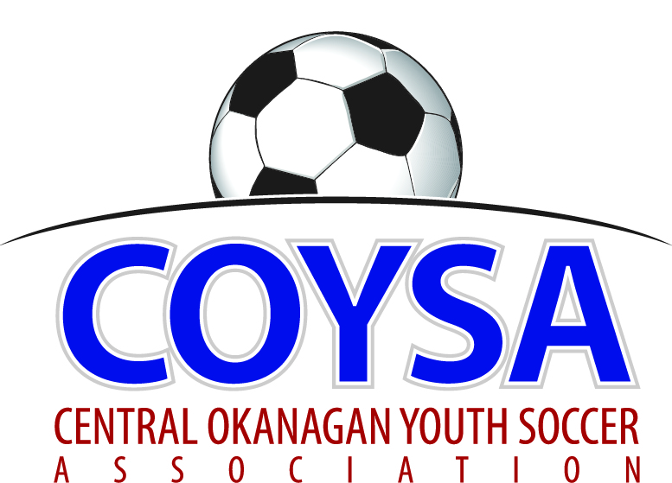
CENTRAL OKANAGAN YOUTH SOCCER ASSOCIATION
District Board Meeting: Thursday, January 12, 2017 7:00pm
COYSA Boardroom, Kelowna, BC

MINUTES
APPROVED (as is/as amended): February 09, 2017 Motion #985
CALL TO ORDER: Roll Call
Will McFadyen, COYSA Chairman, called the meeting to order at 7:00pm and welcomed everyone to the 2017 Board.
Present: Al Ryder (RiC/Ref Sch), Scott Jacobsen (Past Chair), Sheryl Turner (Administrator)
Voting Members Present:
Adil Rajwani
Carrie Smith
Chris Van Demark (for Kelly)
Cliff Jensen (for Chad)
Dan Tauber
Jason Freh
Mike Jilek (for OMYSA)
Oliver Anstice
Randall Wight
Rob Hopkinson
Scott Percival
Surinder Gosal
Total Votes = 12
Regrets: Chad Cormack, Kelly Sherman, Bruce Clark (Discipline), Curtis Morcom (Treasurer)
Everyone introduced themselves around the table.
CONFLICT OF INTEREST FORMS – completed by Board members present.

APPROVAL of MINUTES of the November 9, 2016 regular board meeting
January 12, 2017 Motion #984 It was moved and seconded to accept the minutes of the November 9, 2016 regular board meeting as presented. Carried unanimously.
CHAIRMAN REPORT – written report. Q: Which reports go to the Chairs and which go to the Board? Chair/Club reports go to Chairs, everything goes to the Board.
TREASURER REPORT – written report. Summary of indoor.
REFEREE-IN-CHIEF / REFEREE SCHEDULER REPORT – written report.
DISCIPLINE COMMITTEE REPORT – written report.
ADMINISTRATOR REPORT – written report. Registration ads have been on Castanet 216,194 times since the beginning of December.

CLUB REPORTS:
KUFC – written report. Last weekend had four U13/14 teams in the Pacific Northwest Challenge tournament in Seattle. One team took 1st place. There were over 500 teams.
KYSA – written report
LCYSA – written report.
OMYSA – written report.
Feb 13 from 1-4pm is Family Day event at CNC: 5-600 families. Perfect place for flags/tables and a registration drive. Scott J ran it a few years ago. Divided the field into 3 and kept games running. Scott P will look into.
RYSA - written report
WYSA – written report. U11/12 numbers issue? Can register more than the maximum number but can only dress max number for a game.

COMMITTEE REPORTS
Sponsorship/Promotion (Scott P) – written report.
Mini Jamboree – Still should have a Mini Jamboree. What about doing it at a different time of year; summer / last week of May / beginning of June? RYSA already has Mini World Cup in June. It’s good as a season wrap up. We paid just over $14,000 but that didn’t include any food. Super-8 Soccerfest for 11/12s is 850 players but no meal provided.
Sponsorship - Is there any further development for universal sponsorship? At this point we aren’t because each Club has multi year agreements. Need to look one or two years ahead. Only a couple of Clubs use the same supplier for shirts, shorts. Not pooled together in any way. Bargaining power is better with 5,000. Collectively could save a lot of money. Don’t think anyone has done the number crunching.
Sports Hero awards - Email Scott P if you have a nomination or have your Clubs submit.
Facilities - (Randall) Year in review handout. Where do we stand right now? Has been reviewed by both lawyers and now they have to meet. Randall to send the information by email to Chairs and Board.

CORRESPONDENCE - none

BUSINESS CARRIED FORWARD / NEW BUSINESS
2018 Provincials – (Chris V) If we did it, the catch is volunteers. End of first week of July. Boards change over so this Board could say yes but next Board says no. Would take a monumental effort to get ready for 2018 but maybe 2019. KU not offering to host? No, COYSA. If COYSA was considering it, they could look to subcontracting a professional. For Provincials, there are no fees collected. We lost $4,000 last time. Can apply for grants but no guarantee we would get any. There are opportunities for costs to be recovered. In past, house Clubs were not supportive. We can’t expect that what we put into place, someone is going to volunteer. Why don’t we take it to the Chairs to go to the Clubs. This table will not be here in a year or two. We’d be handing down a legacy that’s a pile of work. A Committee would have to commit to seeing it through even if they aren’t on the Board.
FA Cup idea for one age group U14. Any interest for that? One game lost and you’re out. Why that division, vast difference in skill? Builds excitement and interest. Coaches can learn, recreational kids can learn, a process of development. KU, Tier, Recreational. Opt in? Up to Committee. For half the teams in COYSA it would just be one more game. What about for U13/14 one combined team only per Club? Isn’t that was Div A is now? Adil would look into. This year? Possibly. Fields, refs all to be considered. Lay it all out on paper to go to the Clubs. KU would look at it from perspective of technical advantage. Not wanting to have a Jr Heat team that’s trained 4 days a week for months playing against a team that comes out once a week for fun. Anything for them would have to be in the Fall. Provincials is the goal they work towards all season. No one wants to win or lose badly. What’s best for the kids, it’s about them. Can only ever be two age groups U14-U16. That would be KU U13 and U15. Feedback from Chairs? Similar concerns to here.
Al left at 8:58pm
Technical Direction (Chris V) – The idea behind KU is they are the technical arm of COYSA. Can tailor to every Club. Want to work with the Clubs, not coming in and doing it but work with you to develop your coaches. KU coaches go through coaching mentorship regularly and that affects player development. With the Club Charter, supposed to have a technical lead with a technical program. KU would work with a Club’s technical lead to help develop a program. Each Club might need something different but the message is still the same. What’s required to get the technical requirement for Charter? Needs a Technical Director but it doesn’t have to be in house. It’s the Canadian soccer curriculum, we have to follow that. LTPD (long term player development) puts less pressure on coach to win, even though kids know the score. Do other sports keep score? Any game that follows Canadian Sport does not. KU coaches develop players to whatever level is for that child. We don’t own the kids. The more that we can push to TOFC or higher is an endorsement. The more kids from U10 and under that go on to KU shows how good the house program is. Would be up to KU to provide staff, lots of quality coaches in the area. Ideally would like the same message to everyone as we are one organization.
Soccaskool – not covering tonight.
Committees/Portfolios - Tiering; Facilities; Competitions; Promotion/Sponsorship; Indoor
Tiering – Dan was Chair last year but not returning. Adil will take it on.
Competitions – Dan was Chair last year but not returning. What does this Committee do? Worked with COYSA to make sure the year end tournaments were done, chose medals, figured out who are the Field Marshals. Will bring this and the others back next meeting.
COYSA Vice Chair election - Randall was Vice Chair last year but not returning. Dan Tauber nominated and accepted.
Tournament Sanctioning – not needing to go over.

ADJOURNMENT 9:30pm
NEXT MEETING: Thursday, February 9, 2017 @ 7:00pm

