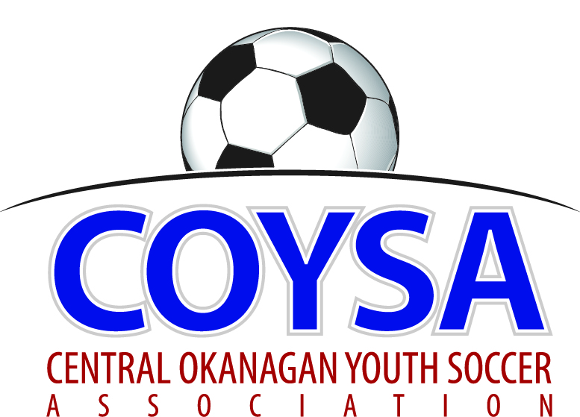
CENTRAL OKANAGAN YOUTH SOCCER ASSOCIATION
District Board Meeting: Thursday, June 14, 2018 7:00pm
COYSA Boardroom, Kelowna, BC

MINUTES
APPROVED (as is/as amended): September 13, 2018 Motion #1029
CALL TO ORDER: Roll Call
Dan Tauber, COYSA Chairman, called the meeting to order at 7:05pm
Present: Sheryl Turner (Administrator)
Voting Members Present:
Bruce Clarke
Carrie Smith
Dan Rodgers
Jae Southward
Jason Scott
Jenn Bernier
Jon McClenaghan
Scott Percival
Sean Irvine
Winston Morgan
Total Votes = 10
Regrets: Francisco Rubio, Bruce Clark (Discipline), Curtis Morcom (Treasurer), Al Ryder (Referees)

PRESENTATION OF AGENDA

CORRESPONDENCE – BCSA AGM review and scholarship luncheon information. Justin Ziebart from Kelowna won the Mansfield award.

APPROVAL of MINUTES of the May 10, 2018 regular board meeting
June 14, 2018 Motion #1025 It was moved and seconded to accept the minutes of the May 10, 2018 regular board meeting as presented. Carried unanimously.

CHAIRMAN REPORT – written report. How many were at the AGM? Maybe 200. Hardly anyone from smaller areas. Talked about ways to do a two way conference to include them. The voting part would be too difficult. Any discussion of moving it around to other locations? No. BCSA year end finances are changing from March to June so AGM will be in the Fall starting in 2019.
Bruce arrived at 7:12pm

TREASURER REPORT – written report

REFEREE-IN-CHIEF / REFEREE SCHEDULER REPORT - written report. Fee proposal put forward so it’s prior to budget for next year. Will this solve the problem or is it cost of living? Bit of both: puts us in a more favorable position and there hasn’t been an increase in quite a few years. How much would it impact our budget? Will get the numbers to Curtis and have him report and we can decide at next meeting.

DISCIPLINE COMMITTEE REPORT – written report. Actual U18 numbers so far this year with just Kelowna Cup remaining: 37. Last year there were 107 total. Coach is responsible for players and parents. If parent is acting up, coach has to deal with them: ref shouldn’t have to.

ADMINISTRATOR REPORT – written report. Thanks to KU’s Scott for the donation of the chairs. This afternoon was at the City’s Sportsfield Advisory Committee meeting. Have been on that Committee for many years and will continue unless anyone has an objection.

CLUB REPORTS:
KUFC – written report.
KYSA – written report. Clubs are responsible for coaches.
LCYSA – written report. Issue with player being super aggressive and ref not calling it. Get ref mentor out for next time.
OMYSA – written report. Call up process is an issue. BCSA wants players at highest level.
RYSA – written report.
WYSA – written report.

COMMITTEE REPORTS
Sponsorship – written report

BUSINESS CARRIED FORWARD / NEW BUSINESS
Anti-bullying – in handout. Take back to Clubs for feedback for September meeting.
One-sided games / fair play – in handout. For when there’s an 8 goal spread we send it to coaches and ask them for a report. If it keeps repeating then would go to Discipline. As COYSA we need the mentality to say we don’t appreciate the score running up, we are not in favour of the big goal differential.
June 14, 2018 Motion #1026 It was moved and seconded to accept the One Sided Game Policy as presented. 9 for; 1 against.
Player pick up – in handout. Would like it changed for all age groups. Want to make it easier to field a team without it being an administrative nightmare. Changes coming. Difficulties in the spring and not just fall. Traditionally fall is the worst.
June 14, 2018 Motion #1027 It was moved and seconded that the Player Pickup Rules apply to all of COYSA. Carried unanimously.
Survey – Everyone’s seen it and given feedback. A few changes made on the last suggestions received.
June 14, 2018 Motion #1028 It was moved and seconded to send out the survey. Carried unanimously.
Bruce left at 9:10pm
Trophies / Kelowna Cup: Went to a lot of expense and effort, should be a good presentation. Field Marshal is there all day representing COYSA and should do a good job.

Tiering: This needs to be looked at to determine what to do: long term look at what is going to happen. Clubs are divided. Tiering seems to be good for some and not others. What’s in the best interest of every kid in the area? Why don’t we make balanced teams? Whole development/competition side of things, the idea is to get like players playing with like players. Good arguments on both sides. Want direction: are we going to tier next year or not? Can we limit the number of teams at KU and then more are in house developing? All are supposed to be developmental. The number of teams at KU is not new. Always had at least two teams in all ages. “A” and “B”. Then their league, TOYSL, went to just “B”. Kamloops wanted to have “A” teams again and then UBCO partnered with KU for Jr Heat, like it does for many sports, and those are “A”. TOFC is a great program with very little turnover. Not all the best players are playing at the level they could be for lots of reasons including cost, commitment, multi-sports. It’s a family choice where the kids play. Tiering Committee is meeting at end of month and will discuss.

ADJOURNMENT: 9:33pm

NEXT MEETING: Thursday, September 13, 2018 @ 7:00pm

