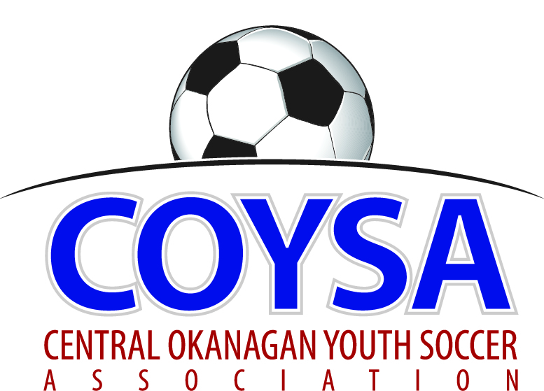
CENTRAL OKANAGAN YOUTH SOCCER ASSOCIATION
District Board Meeting: Wednesday, November 09, 2016 7:00pm
COYSA Boardroom, Kelowna, BC

MINUTES
APPROVED (as is/as amended): January 12, 2017 Motion #984
CALL TO ORDER: Roll Call
Scott Jacobsen, COYSA Chairman, called the meeting to order at 7:13pm
Present: Curtis Morcom (Treasurer), Sheryl Turner (Administrator)
Voting Members Present:
Adil Rajwani
Chad Cormack
Dan Tauber
Jade Banman
Kelly Sherman
Michael Greenhough
Oliver Anstice
Randall Wight
Scott Percival
Surinder Gosal
Will McFadyen
Total Votes = 11
Regrets: Bruce Clark (Discipline), Al Ryder (Ref Scheduler/RIC)
Absent: Alex Vracarevic

PRESENTATION OF AGENDA

APPROVAL of MINUTES of the October 13, 2016 regular board meeting
November 9, 2016 Motion #976 It was moved and seconded to accept the minutes of the October 13, 2016 regular board meeting as presented. Carried unanimously.

CHAIRMAN REPORT – written report. Also want to mention Curtis who is the stewardship on financial side of things. Eight years without an increase and we have added value and programs. Not putting name forward to return as COYSA Chair, wanting to spend more time with family.

TREASURER REPORT – written report. KMPG did the financials. Ran a loss this year, about $15,000. A few reasons: we had a decrease in assessment when we went to the one rate structure, about a dollar per player; field costs are up as we are using more City fields where maintenance and amenities are better; we had fewer registrations; decreased sponsorship and increased coaching development fees. Had mentioned we wouldn’t have to raise assessments and haven’t in 8 years, but based on this, propose we increase $2 and look at 5 year planning. Have been using indoor to offset the outdoor. Indoor is offsetting on some overheads costs but yes we have been taking everything from indoor to outdoor. Would take it to AGM for approval. Field costs are higher, we haven’t billed out for Mini Jamboree but absorbed those costs and took on coaching development. Why not $3? Standard increase is 2% in recreation. Minimum $2, maximum $5? Recommend $3.
November 9, 2016 Motion #977 It was moved and second to endorse the draft financials dated October 31, 2016 as presented and recommend a $3 per player increase in assessment fees. Carried unanimously.
Administrator will find out registration fees from the Clubs. Reminder to ensure there are always two teams per field for practices.
7:47pm Curtis left

REFEREE REPORT – written report.

DISCIPLINE COMMITTEE REPORT – written report

ADMINISTRATOR REPORT – written report

CLUB REPORTS:
KUFC – written report. New Chair: Chris Van Denmark. Kelly and Surinder returning to COYSA Board.
KYSA – written report.
LCYSA – written report. Went with Got Soccer for registration. RAMP was very unhappy. Has Ice Breaker moved? No, it’s on Easter and Easter moves.
RYSA – written report.
WYSA – written report. Do we know if for sure if all the teams are participating in the tiering system? Yes, only OMYSA didn’t last year and they are in this year. As far as Scott not returning, what is the procedure for finding someone new? For COYSA Chair, it’s usually someone from one of the Clubs but technically anyone interested. Can a Club Chair also be COYSA Chair? No, they have to give up their Club affiliation.
OMYSA – had AGM, reduced Board from 18 to 12. New Chair: Mark Hesketh. Past Chair is coming back as Vice Chair and he got volunteers, impartial evaluators and ran evaluations. Will and Scott coming back to COYSA.

COMMITTEE REPORTS
Facilities – Last time we were looking at engineering/ground stuff and a lawyer. Change in KU Board has slowed things down a bit. Waiting for the reviews from both lawyers. Three design firms on the table. Q: is there a time when the Committee should have a rep from each Club? We can move forward with that next year. Q: how does the process work? The partnership agreement is being reviewed, the next piece is the design process and the testing (geo tech). Q: Do we have a date on when we get the agreement? Expecting it soon. Q: Not disbanding Facility Committee at AGM? No. New COYSA Board would reappoint committees at first meeting (January).

Divisional / Competitions – All finished fine. Q: Did you get any help on Competitions Committee? No.

CORRESPONDENCE
Castanet Client Appreciation Nov 17 – circulating. Anyone interested? Administrator will send out.
Valley First New York New Years – in handout. They want us to run an activity, provide the equipment and we can set up a tent and information. Coincides with our registration. Scott Percival will look at doing this.
SK Form & Finish / Mini Jamboree – in handout. They have partnered with us and sponsored the Mini Jamboree for 7 years. They’ve put a lot into it and Angie has spearheaded things from SK’s end. They are now coming to the end of the partnership with us. The Clubs take turns hosting (KYSA is in 2017). As a Board we now need to look ahead to the next Mini Jamboree. Doesn’t have to look the same. Key thing would be that KYSA’s new Board is aware and then make a decision on which direction to go with at our first meeting in January.
Updated Youth Abuse Policy – in handout. Informational.
Canada Soccer / BC Soccer Concussion Policy – circulating. Good policy, good guide. Administrator will send out.

BUSINESS CARRIED FORWARD / NEW BUSINESS
Bylaw changes – One more change – Any objection with tightening the wording to say the alternate rep needs to be a member of the Club’s Board? No objection. One of the other things to look at with the new Board is the Club boundaries in our Bylaws. Areas like Quail Ridge where it is in KYSA but the players primarily go to schools in RYSA. Also is the question of cross-boundary players. Our Bylaws say this Board needs to give approval – do we want a form done? A few years ago we had Clubs track this and they were surprised at how many there were. We don’t want to stop kids from playing but if we have no boundaries then we have the potential of stacking teams. Someone who has been playing for a Club U7-14 and have moved to another area and they want to play with their friends, how hard are we going to go on this? Seems daunting but need a policy.

BC Soccer Associate Membership Update (Scott Jacobsen). A couple of years ago at this table, we had some discussion around private, for-profit academies as we had a question about approving associate membership for a for-profit academy. A lot of it ran counter to our policies so we didn’t approve it. There are a few private academies and was on a conference call with BCSA and surrounding Districts as these are becoming more of an issue. Currently part of the criteria to become an Associate Member, 3 Districts have to approve but based on the discussion, BCSA is revamping their policies. More information coming in the new year.
Money for the Facilities Committee to proceed with the contract to lowest bidder (Dan Tauber). Thoughts were this Board went through a lot of trouble to do with facilities and as a Board we should vote to finish off on it so the Facilities Committee can proceed as whole. Q: Discussion or motion? Motion. Q: Why? We’ll bring in a new Board and start all over again and will be sitting around for 6 months and nothing gets done. Q: What’s different now as we are getting the lawyers looked at, getting quotes? COYSA has voted on a few things but only on proceeding within a limited basis. As COYSA reps we have been looking at the project and should give a clear message to the School District that we are going ahead. As a group we are in favor of the project as a whole and should have a clear thought going forward. Up until now have only said we agree to look at a letter, to look at this. But not saying we are wanting to go forward. Want to see the Board endorse the project pending the things discussed last meeting. We can disagree and give opinions but we have to be civil. Good idea as when the new Board comes, we lose this year’s worth of discussion and we were all part of this. It took 10 years and everybody was in agreement of the process and the history will almost be wiped clean and the group that comes back will sit here and say we talked about that for a year and now we are doing it again. For the most part, everybody agrees it is good for soccer. Soccer centred facility (only soccer lines). A motion contingent on the agreement being ratified by the two lawyers. Dan is looking for endorsement. Don’t think we need to do it, it’s already in motion. Concern is we don’t want to rework it all. Not revisit it all again in the new year. We are moving forward but an endorsement would be nice. Can we do a motion that includes the two concerns: lawyer agreement and 3 bidders? To make sure the next Board knows we are moving forward.
November 9, 2016 Motion #978 It was moved and seconded that this Board endorses the COYSA Super-8 turf field facility project pending approval of the legal review of the partnership agreement between COYSA and KU and the receiving and approval of 3 design bids by the COYSA Board. 10 for; 1 against. Motion carried.
In essence it’s what we are doing, but it’s in writing now.

ADJOURNMENT 9:14pm

NEXT MEETING: COYSA AGM: Wednesday, November 30, 2016 @ 7:00pm

