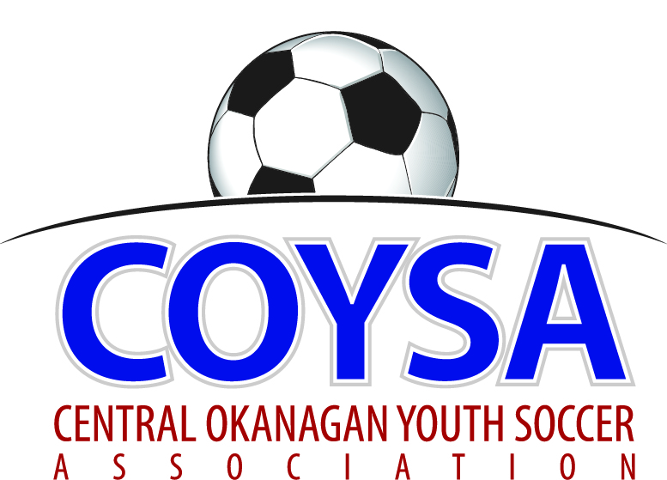
CENTRAL OKANAGAN YOUTH SOCCER ASSOCIATION
District Board Meeting: Thursday, September 8, 2016 7:00pm
COYSA Boardroom, Kelowna, BC

MINUTES
APPROVED (as is/as amended): October 13, 2016 Motion #973
CALL TO ORDER: Roll Call
Scott Jacobsen, COYSA Chairman, called the meeting to order at 7:16pm (had to wait for a quorum)
Present: Curtis Morcom (Treasurer), Al Ryder (Ref Sch/Referee-in-Chief), Sheryl Turner (Administrator)
Voting Members Present:
Adil Rajwani
Dan Tauber
Kelly Sherman
Oliver Anstice
Randall Wight
Surinder Gosal
Will McFadyen
Total Votes = 7
Regrets: Bruce Clark (Discipline), Alex Vracarevic, Chad Cormack, Jade Banman, Michael Greenhough, Scott Percival
No show: Trevor Downey (for Chad)

PRESENTATION OF AGENDA

APPROVAL of MINUTES of the June 9, 2016 regular board meeting. Comment about the change in minutes – names are not included as per the Society workshop.
September 8, 2016 Motion #971 It was moved and seconded to accept the minutes of the June 9, 2016 regular board meeting as presented. Carried unanimously.

CHAIRMAN REPORT - Lots of activity around the District but quiet at the office side. Some behind the scenes going on with Facilities.
TREASURER REPORT – written report. Will be pretty close to being exactly on budget.
REFEREE-IN-CHIEF REPORT/REFEREE SCHEDULER – written report. Canada Day Tournament went off relatively smoothly. First couple of weeks filled and confirmed. Ran an Entry Level course. This fall have lost a fair number of experienced refs plus they were being used as mentors. Kelowna needs to find a new Mentor as Darnell was theirs. Have put together a google sheet with all refs to track who has been mentored. Been using the new headsets over the last couple of months. Used them as an official and as a mentor. Got one for indoor. Huge asset. Thanks for stepping up as RIC.
DISCIPLINE COMMITTEE REPORT – written report.
ADMINISTRATOR REPORT – written report.
Al left at 7:36pm

CLUB REPORTS:
KUFC – written report.
KYSA – written report. Wondering about going to a straight U13 group next year. Lose a lot of U13 players that don’t make the U14 Div A team as they want to play at a higher level. New thing from BCSA is the new rule for U13 to have to do retreat line. Probably a Tiering/Divisional Committee discussion. Will clarify with BCSA.
LCYSA – no reps; no report.
OMYSA – written report.
RYSA – written report.
WYSA – written report.

COMMITTEE REPORTS
Facilities – slide show presentation. Information to take back to your Clubs. Should be easy to present to Clubs or let Randall know if you want him to come. Biggest thing is the estimate cost $484,400 with LED lights and $380,200 without lights. Field already exists so don’t expect any surprises. Maintenance is opening / closing and fluffing the turf. Will be fenced and that’s included in the estimate. Can we have a storage unit? Possibly a container. We can have our own place for developing our coaches and players. It’s not what one Club is going to get out of it. We can sit here and go ‘what if’ and never get anywhere. We are going through the process. SD23 wants to work with us if this goes well. Long term plan so everyone could have something in their catchment area. Possibly re-implementing the facility fee charged to members as before. Life of field is approximately 15 years. Future reserve fund is for repairs and replacement. We could charge COYSA one rate and then others a different rate. Look at CNC fields; they are over ten years and haven’t been replaced. UBCO just had theirs tested as it is over 8 years old and it has a good 8 more years and it’s used year round. Thanks to Randall for all the work on this.
Curtis left at 8:35pm
Divisional/Tiering – Nothing going on; just in a lull right now.

CORRESPONDENCE
Okanagan Leadership Conference
KidSport Week information

BUSINESS CARRIED FORWARD / NEW BUSINESS
Coaching Development – BCSA has changed how they are formatting their licensing. Pre B is gone and is replaced with the new Provincial C. We’ve paid for Community courses but do we want to support coaches to take Provincial C? It’s about $500. Good for the technical development of Clubs. 50/50 is good. Big commitment for coaches. Not just the 3 or 4 day course but pre-work and then evaluation after. Maybe a 3 way split. Person taking it, COYSA and Club. Does COYSA support at subsidizing at 50% and then up to Clubs if they want to contribute? Affects / involves head coaching to do with Club Charter. Should be experienced coaches that take it. Must have the ability to get through the course. Need a description to send to Clubs.
September 8, 2016 Motion #972 It was moved and seconded that COYSA will reimburse ‘Club submitted coaches’ 50% of the C license course cost upon completion of the course including the evaluation portion. 6 for; 1 abstained. Carried.

ADJOURNMENT 8:56pm

NEXT MEETINGS:
Thursday, October 13
WEDNESDAY, November 09
AGM: Wednesday, November 30

