Cochrane Ringette Association Sports Injury Report Form
Injury details: This report reflects an accurate record of the injured person’s reported symptoms of injury

Name of person injured: |  |  |  |  |  |  |  |  |  |  |  |  |  | DOB: |  |  |  | / | /
 |  |  |  |  |  |  |  |  |  |  |  |  |  | (Day/Month/Year)
Date when injury occurred: |  |  |  |  |  |  |  |  | / |  | / |  |  | Team & Division:
Person injured: Athlete Coach Other: |  |  |  |  |  |  |  |  |  |  |  |  |  | Gender: | M |  | F
Supervising coach: _______________________________ |  |  |  |  |  |  |  |  |  |  |  |  |  | Witness:
 |  |  |  |  |  |  |  |  |  |  |  |  |  | ___________________________________
 |  |  |  |  |  |  |  | (Signature) |  |  |  |  |  |  |  |  | (Signature)
First aid provided by: |  |  |  |  |  |  |  |  |  |  |  | Time of |  |  |  |  | Initial treatment:
 |  |  |  |  |  |  |  |  |  |  |  |  |  |  | :
___________________________________________ |  |  |  |  |  |  |  |  |  |  |  | first aid: |  |  |  |  | No treatment required
 |  |  |  |  |  |  | (Signature) |  |  |  |  |  |  |  |  |  | CPR | RICER
Nature of injury: |  |  |  |  |  |  |  | New injury |  |  |  | Aggravated injury
 |  |  |  |  |  |  |  | Recurrent injury |  |  |  | Other: |  |  |  |  | Crutches | Sling/splint
Did the injury occur during… |  |  |  |  |  |  |  |  |  |  |  |  |  |  |  |  | Dressing | Strapping
Training |  |  |  |  |  |  |  |  |  |  | Game: | Other: |  |  |  |  | Massage | Stretching
Symptoms of injury:
Blisters |  |  |  |  |  |  |  |  |  |  | Inflammation/swelling |  |  |  | Spinal injury
Bleeding nose |  |  |  |  |  |  |  |  |  |  | Cramp |  |  |  | Cardiac problem
Bruising/contusion |  |  |  |  |  |  |  |  |  |  | Suspected bone fracture/break |  |  |  | Electrical shock
Cut |  |  |  |  |  |  |  |  |  |  | Dislocation |  |  |  | Burn
Graze/abrasion |  |  |  |  |  |  |  |  |  |  | Concussion/head injury |  |  |  | Insect bite/sting
Sprain |  |  |  |  |  |  |  |  |  |  | Loss of consciousness |  |  |  | Poisoning
Strain |  |  |  |  |  |  |  |  |  |  | Respiratory problem |  |  |  | Other:
Body part injured: |  |  |  |  |  |  |  |  |  |  | How did the injury occur?
 |  |  |  |  |  |  |  |  |  |  | Collision with a fixed object |  |  |  | Overbalance
 | right |  |  | left |  |  | left |  | right
 |  |  |  |  |  |  |  |  |  |  | Collision/contact with another |  |  |  | Overstretch
 |  |  |  |  |  |  |  |  |  |  | person
 |  |  |  |  |  |  |  |  |  |  | Fall from height/awkward landing |  |  |  | Slip/trip
 |  |  |  |  |  |  |  |  |  |  | Fall/stumble on same level |  |  |  | Other:
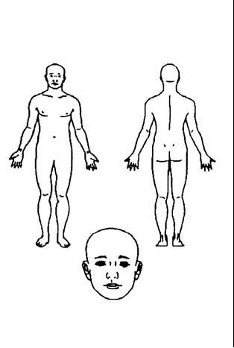
Extra detail regarding how the injury occurred:

 | Was protective equipment worn on the injured body part? |  |  | Yes No
Follow up action: | None | Medical practitioner/physiotherapist |  | Hospital
 | Ambulance | Other:
Signature of person completing form: |  |  | Date: | / | /

Note: Coaches without medical training should refer all medical decisions to appropriately qualified persons. Do not attempt to ‘diagnose’ an injury. Users of this form are advised that medical information should be treated confidentially.

**If suspected concussion please refer to concussion return to play guidelines**

