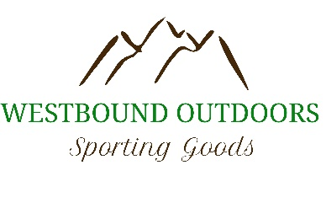
Player Name ______________________________________
Contact Info _______________________________________
We will do our best to make your order to your specifications. Westbound Outdoors/ Didsbury Minor Hockey Association will not be responsible if it is not completely legible and spelled and spaced out on this form for us. Please bring your completed form to Westbound outdoors during business hours with payment.
THERE WILL BE TRY ON SAMPLES AVAILIABLE BE SURE TO USE THEM
If there is more than one colour choice, please circle which one you would like. Please circle your size and colour choice
If you want name and/or number on your shirt Please write in the box the exact spelling, spacing and capitalization! If it is not on the form it will not be on the shirt.
All Logos will be done to the standard for that Colour and Style.
Item Colour Name Number Size Cost Total
Short sleeve shirt | Black  kelly green |  |  | Youth S M L XL  Adult S M L XL XXL XXXL | 30.00
Long sleeve shirt | Black  Kelly Green |  |  | Youth S M L XL  Adult S M L XL XXL XXXL | 35.00
Pro team shorts | Black | NA | NA | Youth S M L XL  Adult S M L XL XXL | 24.00
Striped hoodie  (allow 4-6 weeks delivery) | Black /green |  |  | Youth S M L XL  Adult S M L XL XXL XXXL | 60.00
Youth two tone hoodie  100% poly | Green/black |  |  | Youth S M L XL | 60.00
Vintage two tone hoodie  60/40 cotton/poly | Green/black |  |  | Adult S M L XL XXL XXXL | 60.00
Insulated jacket | black |  |  | Youth S M L XL  Adult S M L XL XXL XXXL | 100.00  120.00
ATC cotton hoodie | Black  green |  |  | Youth S M L XL  Adult S M L XL XXL XXXL | 40.00
Ball cap | Black/black  black/white | na | na | Toddler-child  Child -youth  Small med  Med/large  large | 22.00
Pom pom toque | Black grey | na | na | One size | 16.00
Black plain toque | black | na | na | One size | 15.00
KOBE Warm up pants | black |  |  | 4/5  6/8  10/12  Xxs  Xs  M  L  Xl  Xxl  xxxl | 45.00
Warm up jersey | Black  White  green |  |  | Youth small/ med  Youth large/xl  Adult sm, med, large, xl, goalie | 35.00

Player Sub Total $ _________
Tax X 5%. $_________
Player total $ _________

