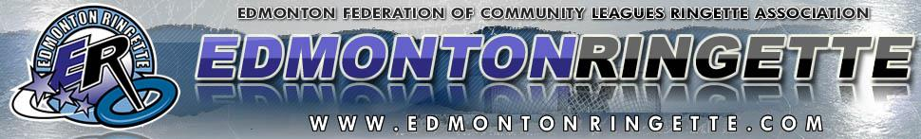

To whom it may concern:
Re: Edmonton Ringette Bottle Drive

Please be advised our athletes are now out in full force, fundraising for the 2016-2017 season. Help support them by donating any empties you have – it will go a long way to ensuring a successful year on and off the ice!

Thank you,
Marcie Arnold, President
Edmonton Ringette (EFCLRA)

