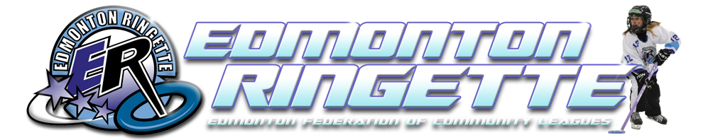
Edmonton Ringette invites you to take part in the “Fastest Game on Ice”, and make Friends for Life
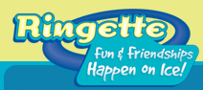
Edmonton Ringette will host FREE Come Try Ringette Events in the summer and fall, check out the website for updates.
Next Event is July 12, 2015 4:30pm at Clareview Arena, 3804 139 Avenue
www.cometryringette.ca or www.edmontonringette.com

Want to register? Join us as a new player for only $199, please contact Shannon Langstrom admin@edmontonringette.com for more information.

All players aged 5- 18 welcome!

