How to Score a Game
Note: It does not matter if you won or lost, please score your game

Step 1: First Login in, go the EYBA website (www.edmontonyouthbasketball.com) and locate the “LOGIN” button located in the top right hand corner.

Step 2: Log in. User name and password – EYBA will have sent you a user name and password

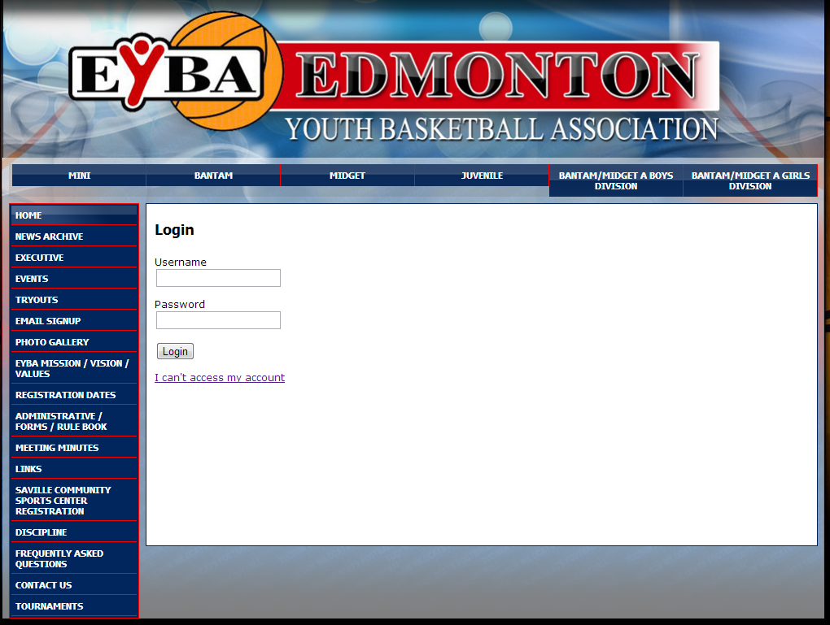

Step 3: Click on the “statistics tools” button to score your game

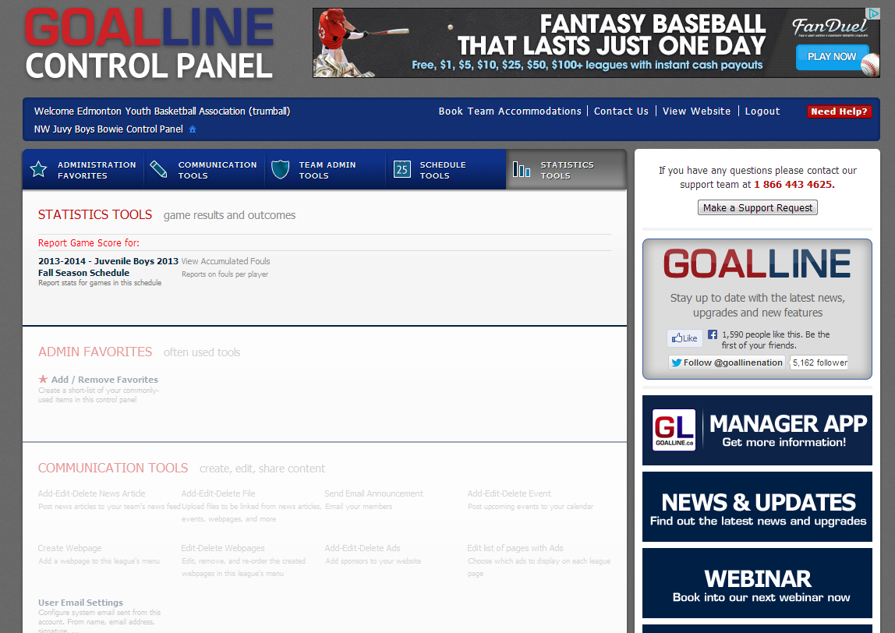
-2-

Step 4: Find the game you want to score and click on “Report”

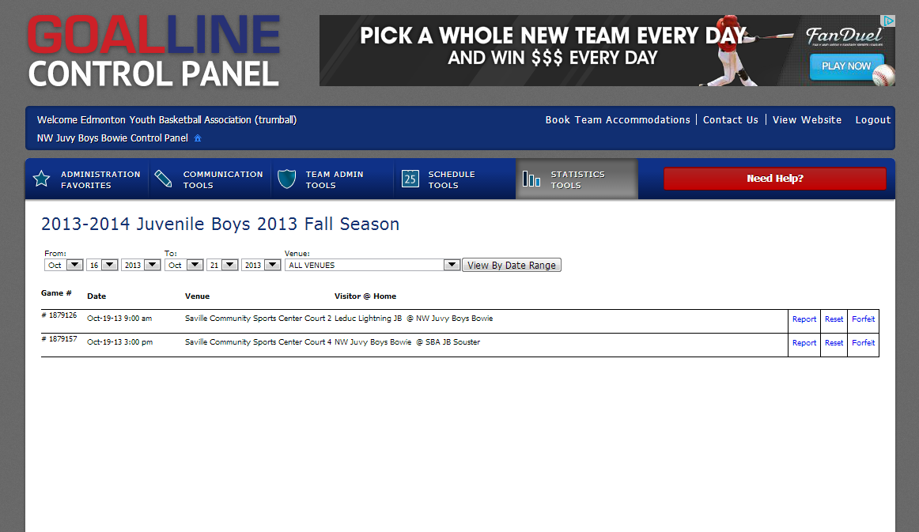

Step 5: Enter the Score and click on “submit game report”

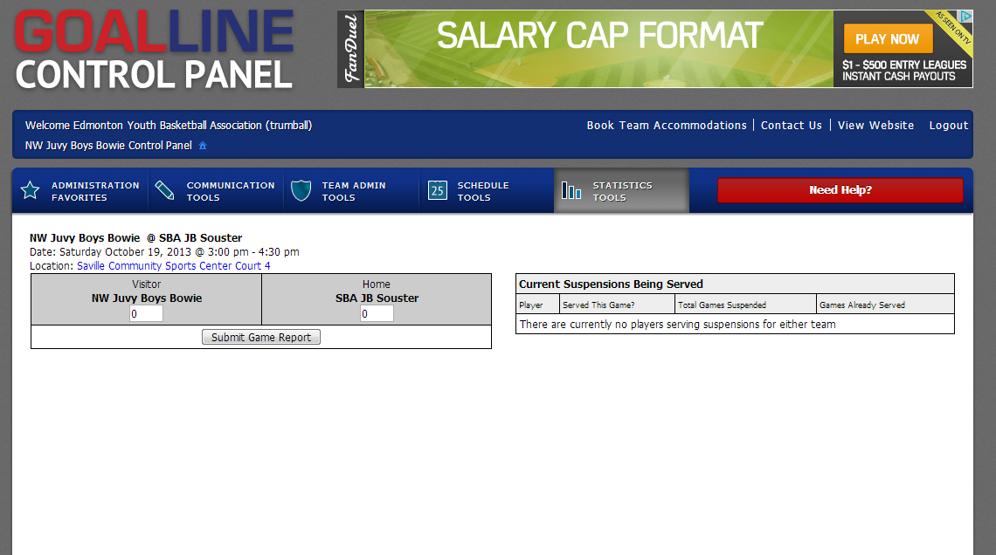

Step 6: You are done.

OR
If your game is at the “Saville Sports Center” you can turn in the white copy at the front desk, where the attendant sits. BUT please score your game when you get home.

