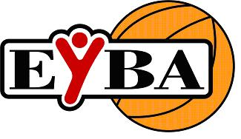
EYBA Semi - Annual General Meeting
Sunday November 16th, 2014
Saville Community Sports Center
U of A South Campus, Classroom #1, 6:30 pm

PARTICIPANTS: Chad Bowie, President
Carr Miceli, Vice President
Lynn Hyska, Treasurer
Darlene Anstice, Secretary
Shaun Pope, Executive Director
Pierre Farage, SE
Lynn Hallson, SW
Brad Coleman, NW
Mark Mathias, Morinville
Paul Looker, St. Albert
Derek DeKlerk, Leduc

REGRETS: Brian Anstice, Commissioner
Kevin Hofestede, NE Zone
Chuck Hebert, Wetaskiwin
Chris Billings, Beaumont
Dave Oldham, Parkland

- Call to Order, Welcome and Attendance @ 6:30pm
- Acceptance of Previous Minutes
  - EYBA Annual General Meeting – April 27, 2014
    - Motion made by Carr Miceli to accept minutes with the revision for team fees to read $1250 for city teams & 1100 for out of town teams / 2nd by Derek DeKlerk / motion carried
- Additions and Approval of the Agenda
  - Motion to approve agenda made by Lynn Hyska / 2nd by Paul Looker / motion carried
- Agenda Items
  - Reports
    - Treasurer’s Report/Budget
      - Lynn Hyska read out information from the documentation she prepared for the meeting, including:
        - General Account - $293,227.95
        - Term Deposit - $250,000.00
        - Casino Account - $81.95
      - Lynn Hallson & Al Lee have both reviewed the EYBA books and all is fine.
        - MOTION made by Pierre Farage to approve financial statements as presented / 2nd by Mark Mathias / MOTION CARRIED

- Close and Adjournment @ 6:37pm
  - MOTION to adjourn meeting made by Brad Coleman / 2nd Paul Looker

