Edson Minor Soccer Association

Request for Refund

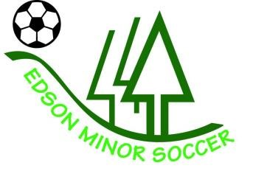

Policy: A full refund will be given only if the league is canceled due to insufficient registration. Refund requests other than insufficient registration numbers must be made in writing and submitted on this form. All requests will be reviewed and refunded at the sole discretion of board members.

Deadline: Refund Requests must be made by Monday, May 7, 2018.

Eligibility: The person who made the original payment may receive a refund, less the processing fee, if approved by the Edson Minor Soccer Executive. Medical refunds will be prorated based on the number of games remaining in the season at the time the request for refund was received.

Processing Fee: A $15.00 processing fee will be deducted prior to the payment of any funds.

Payment of Refund: Refund cheques will be issued by the last day of May 2018, for the Outdoor Season.

Please complete and submit this form by May 7, 2018 to this address:

Edson Minor Soccer Association
PO Box 7894
Edson AB T7E 1V9

Name of individual who paid for original registration: ____________________________

Player’s name: _________________________________________________________

Player’s age group & league: _____________________________________________

Amount and date of original payment: _______________________________________

Receipt # of original payment:_______________________________________________

Mailing Address (to send refund): __________________________________________

Reason for Refund Request: ______________________________________________

Approved on behalf of the Board:

___________________________ ____________________________
(Board Member) (Date)

