NORTHWEST CENTRAL



SOCCER ASSOCIATION

TABLE OF CONTENTS

GENERAL PHILOSOPHY 3
NORTHWEST CENTRAL SOCCER ASSOCIATION OVERVEIW and STRUCTURE. 4
RULES AND REGULATIONS SPECIFIC to NWCSA 6
NWCSA Team / Player Permission to take part in a Sanctioned Tournament 7
PROPOSED ALIGNMENT of Dates for NWCSA Communities 8
NWCSA LEAGUE PLAY 9
NWCSA LEAGUE GAME SHEET 10
NWCSA DISCIPLINE POLICY 11
NWCSA REFEREES and POLICIES 14
NWCSA EXPENSE FORM 16
REFEREE MISCONDUCT REPORT 17 + 18
RECOMMENDATIONS for SOCCERFEST 19
NWCSA SOCCERFEST (2 Team Round Robin format) 20
NWCSA SOCCERFEST (3 Team Round Robin format) 21
NWCSA SOCCERFEST(4 Team Round Robin format) 22
NWCSA SOCCERFEST (5 Team Round Robin format) 23
NWCSA SOCCERFEST (6 Team Round Robin format) 24
NWCSA SOCCERFEST (7 Team Round Robin format) 25
NWCSA SOCCERFEST (8 Team Round Robin format) 26
ALBERTA SOCCER ASSOCIATION ACCIDENT INSURANCE CLAIMS PROCEDURE 27
SPORT ACCIDENT CLAIM FORM 28
SPORT ACCIDENT CLAIM FORM ("Other Insurance") 29

Northwest Central Soccer Association would like to thank Mr. Bill Semenyna for all his time and effort put forth in making this handbook possible.

GENERAL PHILOSOPHY GOVERNING NWCSA

The ideals established by the “Commission of Fair Play” in 1986 by the minister for Fitness and Amateur Sport will be adhered to by NWCSA.

Guidelines:
1. Respect for rules.
2. Respect for officials and acceptance of decisions.
3. Respect for the opponent.
4. Concern for equal opportunity.
5. Maintenance of dignity under all circumstances.

Fair play thrives with the right attitude, sportsmanlike behaviour and a positive environment and becomes evident when:

- Coaches and participants respect the rules, officials, and their rulings.
- Opponents are treated with respect.
- The team does not take an unfair advantage over its’ competitors.
- Everyone involved with the game behaves in an exemplary fashion.

When an inappropriately high value is placed on winning, the true meaning of sport is forgotten. Regardless of the circumstances the rules of fair play apply:

- There is no room for killer instincts or intimidation.
- The outcome of the game should not be based on the psychological or physical harassment of opponents.
- Deceit is never an acceptable means to an end, even when rules of the game are not technically broken.
- Coarse language and insulting remarks clearly fall outside the boundaries of fair play.
- Winning at all costs must be discouraged.

The intercommunity soccer program is a valuable teaching tool. It is about winning and it is about losing. The soccer program is about everybody; athletes, coaches, the public, but most of all it is about playing the game fairly. Fair play is about respect for opponents, the officials, and the public. There is nobody better to communicate that message than the young, through their participation in community, and intercommunity soccer programs.

To enthuse us in the love of soccer, athletes and coaches can serve as an example to all. By playing fairly we can all be “winners”.

NORTHWEST CENTRAL SOCCER ASSOCIATION

OVERVIEW:

Northwest Central Soccer Association (NWCSA) is an organization made up of communities in the Alberta Soccer Association (ASA). The member communities extend from Stony Plain in the East, to Jasper in the West, Drayton Valley to the South, and Whitecourt to the North, with Hinton, Edson, and Evansburg in between. There are other communities within the boundaries of NWCSA but as yet do not have programs that are with NWCSA. NWCSA is one of eighteen soccer districts in Alberta and is considered one of the nine “rural” districts.

NWCSA functions and objectives include:
- Representing the district at Alberta Soccer Association meetings.
- Administering the collection of fees to be paid to ASA.
- Organizing and promoting Tier IV and Tier III “traveling league” between the member communities in the outdoor season.
- Organizing and promoting a Tier II program for the higher level players in the district.
- Helping to organize and run the Suburban League, along with Sherwood Park, in the indoor season.
- Declaring teams and paying fees for Provincial Competitions at the Tier IV, Tier III, and Tier II levels.
- Providing technical expertise and assistance to member communities through ASA Technical Assistants and the NWCSA District Head Coach.

NORTHWEST CENTRAL SOCCER ASSOCIATION STRUCTURE:

NWCSA has an executive made up of the community representatives participating within the District. NWCSA meets a minimum of two times each year to carry out the business of operating a soccer district; the Spring Planning Meeting (held in March) and the Annual General Meeting (AGM) held in September. At least one representative from each member community is required to be in attendance at the meetings. It is expected that each member community be willing to serve in some capacity to enable NWCSA to function.

Spring Planning Meeting: Setup of league play, team declarations, Soccerfest hosts, etc.

Annual General Meeting: As of September, 2010, the Board Positions are 2 Year Terms. The AGM must be held between September 1, and October 30, each year.

The following positions are required to be filled:
- President
- Vice President
- Secretary
- Treasurer
- Registrar
- League Scheduler

Please Note: Community Representatives will be reimbursed at $0.20/km (each way) for attending the mandatory Northwest Central Meetings, as approved on March 28, 2009. Application for remuneration must be submitted to the Treasurer using the NWC Expense Form (page 16).
LEVELS OF PLAY

The Alberta Soccer Association, in recognizing the unique challenges of delivering a quality soccer program in areas of relatively low population, has designated NWCSA as a “rural” district. This designation allows NWCSA a number of advantages not afforded to the larger “urban” districts. NWCSA players can play in more than one Provincial Competition.
NWCSA Tier IV house league players can play in a Tier IV Provincials and a Tier III or Tier II Provincial.
NWCSA Tier III players can play in a Tier III Provincials, and a Tier II Provincials.
This allows NWCSA to offer players from any community in the district an opportunity to play at the Tier IV, Tier III, and Tier II levels.

- Tier IV: Tier IV is where a traveling schedule is constructed. Teams from the member communities travel to each other’s towns and play two games on a Saturday, during May and June. The host community is responsible for providing a schedule and officials for these games. Playing two games on a Saturday came about in an attempt to minimize the time and expense of travel. Another initiative has been to schedule games, involving the communities furthest apart, at a central venue whenever possible. The Tier IV schedule has built in spaces in the schedule to allow teams to go to tournaments in other districts.
- Tier III: The Tier III program functions the same as the Tier IV.*
- Tier II: The Tier II program involves forming some of the better players into a team. The team then receives extra training sessions and tournament games to prepare them for Tier II Provincial Competition in September.
- Tier I: There is no program offered through NWCSA for this level at this time.

*Please Note: Teams may declare Tier IV or Tier III prior to the start of the season. Due to the fact that there are usually fewer Tier III teams declared, the Tier IV and Tier III teams will play during the regular season against each other. However, the Tier III teams will not compete in the Tier IV Soccerfest.
Further, Tier III teams may be formed from the Tier IV program to represent the district in Provincials (if there is not already a Tier III community team declared from that age group). This would be a select team, much like the Tier II program.

BY-LAWS, GENERAL RULES, AND REGULATIONS

The Northwest Central Soccer Association operates under the Alberta Soccer Association. As a result, NWCSA must operate under the rules, regulations, and by-laws established by ASA. The by-laws, rules and regulations can be obtained on line from ASA or they may be sent directly to your community organization if your community is registered with ASA. The by-laws, rules, and regulations are updated annually by ASA.
All soccer organizations must be registered as not for profit organizations according to the Alberta Societies Act to be members of NWCSA.
Rules governing competition are outlined in the Youth and Senior Outdoor Competition Rules booklet. NWCSA is required to follow these rules set out by ASA.

RULES AND REGULATIONS SPECIFIC TO NWCSA

- Releases/Transfers: As per ASA Rule 4. A) iii) (2008) Individual youth players will be allowed to register for other District youth teams as always, provided they follow standard procedures in the new District. Once a youth player has registered with his/her new District, it will be the responsibility of the gaining (new) District to inform the losing District of the particulars of said youth player(s). Entire teams will not be allowed to leave a District that offers the level of competition they are playing in without the written permission of the home District. Individual releases cannot be used to form a team outside the District of domicile without the approval of the home (losing) District. In keeping with FIFA laws, the ASA Board of Directors has determined that a team under this rule must be considered to be a minimum of seven (7) players.
- Blanket Release of adult players: Northwest Central Soccer Association voted unanimously on September 29, 2002 to provide a blanket release from NWCSA to EDSA only for adult male and female players. Separate releases are needed for outdoor and indoor seasons each year.
- Tier IV Soccerfest Eligibility: A team must participate in 75% of NWCSA league play in order to be eligible for the Soccerfest. (as of March 28th,1999)
- Tier IV Soccerfest results: Communities hosting a NWCSA Soccerfest must submit the results to the NWCSA President within 48 hours of the end of the competition. Winner of the Soccerfest proceeds to Tier IV Provincials.
- Tier IV Provincials: Teams wishing to represent NWCSA at Tier IV Provincials (in July) must declare their intention at the March meeting of NWCSA.
- Tier III Provincials: Teams wishing to represent NWCSA at Tier III Provincials (in August) must declare their intention at the March meeting. If there are more than two teams declaring in Tier III, they must playoff for the right to represent the District. Playoff site will be determined by NWCSA.
- Team Roster Submission: Tier III and Tier IV team rosters must be submitted to the NWCSA Registrar by May 15.
- Tier II operation and organization:
  - Coaches are to submit a written application stating qualifications, and brief coaching history at the March meeting of NWCSA.
  - After being approved by NWCSA the Coach will choose assistant coaches and team manager (usually from parents of players chosen to be on the team).
  - The Coach is responsible for selecting the players for the Tier II team. The District Head Coach, if requested by the Tier II team Coach, can recommend players to the selection process and be involved in the training of the team once the selections to the team have been completed.
  - Tier II Team roster Submission: Tier II team rosters must be submitted by the 2nd weekend of July to the NWCSA Registrar.
- Roster Changes: Any changes to the original roster MUST be made 7 days prior to Soccerfest, and must be approved by the Registrar and President.

All coaches must have a Criminal Records Check or an Alberta Services Intervention Record Check. ASA now requires proof of these forms, prior to competing/coaching in Provincials.
EACH COMMUNITY SHALL BE RESPONSIBLE for any of their teams withdrawing from Provincials, and shall be subject to remit to Northwest Central the following:
The original Declaration Fee (varies in amount by age group, around $500)
The ASA Administration Fee ($500)
And a possible Withdrawal Fee ($2000) imposed by ASA

Northwest Central Soccer Association

Re: Team/Player Permission to take part in a Sanctioned Tournament

Date:

To Whom it may concern:

Northwest Central Soccer Association hereby gives permission for:
(name of team)
from (name of community)
to participate in the (name of tournament)

OR

(name of player)
from (name of community)
to participate in the (name of tournament)

Signed by ,

President, Northwest Central Soccer Association

Guest Players Permission
(name of player) is hereby granted permission to play as a guest player on (name of team participating in tournament)
signed by (coach of regular registered team)

PROPOSED ALIGNMENT OF DATES FOR NWCSA COMMUNITIES:

ACTIVITY: DATE: PERSON/GROUP RESPONSIBLE

General registration 1st week in March Community Organization

Travel team declarations March NWCSA meeting Community NWCSA Rep

Travel team contact list March NWCSA meeting Community NWCSA Rep

Soccerfest hosting declarations March NWCSA meeting Community NWCSA Rep

Coach’s course dates March NWCSA meeting

Referee course dates March NWCSA meeting

Tier II coach application March NWCSA meeting NWCSA Board Approval
(submission and approval)

Referee scheduling and list 3rd week in April Community Organization

Tier IV and III travel schedule Mid April NWCSA Scheduler

Travel Team ASA Rosters Deadline April 15 NWCSA Registrar
(Tier III and Tier IV)

All house league ASA Rosters Deadline May 15 NWCSA Registrar

Community ASA fee payment Deadline May 15 NWCSA Treasurer
(plus NWCSA fee, plus coaches fee)

Tier II ASA form 2nd Weekend in July Tier II Coach / NWCSA Registrar

NORTHWEST CENTRAL SOCCER ASSOCIATION LEAGUE PLAY

SCHEDULING:
- To ensure that all visiting teams have adequate time to respond to weekend game schedules, it is imperative that Host Communities forward a copy of the proposed schedule to the visiting teams by Tuesday, prior to the weekend games. This will allow visiting teams to respond by Wednesday, which in turn allows the Host Community adequate time to make necessary alterations.
- If a team cannot make the scheduled dates, they can contact the other coaches to sort out other options. However, they must let the scheduler know. Example: Playing in the evening during the week. In extreme circumstances, playing in the Camrose Night Classic Tournament, Sherwood Park Optimist Tournament, etc, may count towards make-up games.

LEAGUE PLAY:
- The host community must play the first game and the last game of the day; the host community does not have to travel.
- Prior to schedules being sent out to visiting teams, it must be proof read by the community outdoor coordinator(s).
- Alterations may include changes in the number of referees, fields, and change of playing times to meet the needs of visiting teams.
- NWCSA Representatives are responsible for giving Coaches and Managers a copy of the NWCSA Contact List.
- The MAXIMUM allowed bench personal is limited to three (3) members (coaches, managers, etc) and must be on the ASA Registration Sheet. Only exceptions are substitute coaches, etc. As per ASA rules, any team with a female player MUST have a female personal member with the team at all times (including practices). This personal member MUST BE on the ASA Roster as either a Manager or Attendant.

The win loss statistics are to be kept by the community that volunteered to host the NWCSA Soccerfest for that particular age category and gender. This is necessary to determine the proper seeding for the District Soccerfest.

FORMS:
- NWCSA Game Sheets are to be submitted to the Host Community coach and then that person is to forward them (either verbally or hard copy) to the Community hosting the District Soccerfest.
- All travelling team coaches must have a yearly ASA Competitions Handbook and a NWCSA Handbook.

HOSTING:
- Hosting Communities MUST appoint a FIELD MARSHALL for weekend play to handle any and all emergency response matters and to ensure the host coach(s) have done the proper field set up. The Field Marshall cannot be the hosting coach or any of the referees. (see page 19 for Field Marshall duties)
- The host coach(s) are responsible for field setup, field cleaning, and field take down.
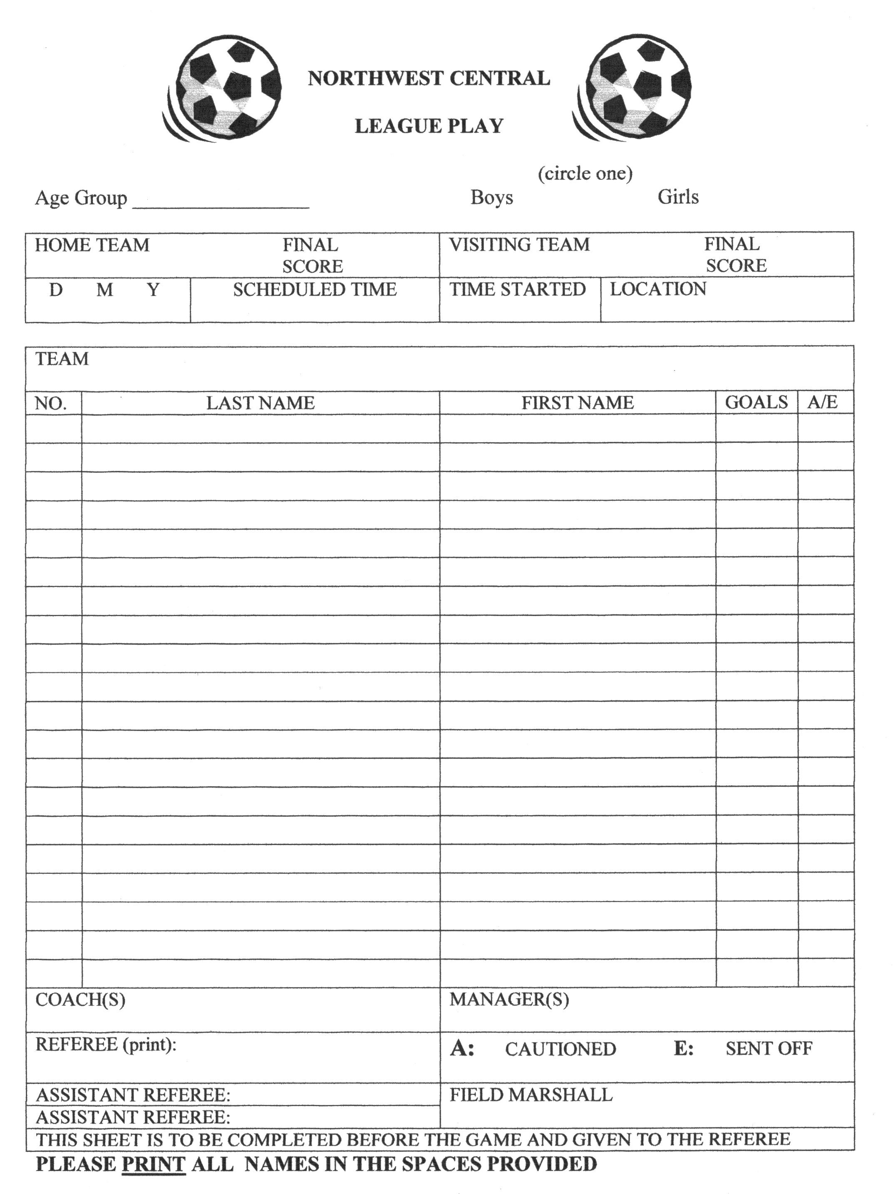

NWSCA DISCIPLINE POLICY

1. This policy applies to all games played under the auspices of the Northwest Central Soccer Association.

2. All decisions of the referee are final and may not be appealed.

3. The District Referee Assistant (RA) is responsible for handing down suspensions.
a. If the District RA participated in the match regarding the incident, the suspension will be passed onto one of the members of the Disciplinary Committee who had no part in the match.

4. The Northwest Central Discipline Committee shall be composed of the following individuals*:
- District RA
- District President
- District Vice-President

*NOTE: If any of these individuals are affiliated with one of the teams involved in the incident, the Discipline Committee shall be composed of representatives from three (3) neutral communities instead.

5. The RA is responsible for tracking all yellow cards, red cards, and game ejections.
a. After the game, the referee must notify the Town Representative who, in turn, must inform the RA of any yellow cards by giving the following information:
- Players Name
- Team Name
- Age Group
b. After the game, the referee must notify the Town Representative who, in turn, must inform the RA of any red cards by giving the following information, as well as a Misconduct Report detailing the incident:
- Players Name
- Team Name
- Age Group
- Reason for Sending Off
c. The RA will inform a team official of the accused with the details of the
suspension.

6. Suspensions will carry over to the next games scheduled for that team with the exception of Provincials, which fall under the guidelines of the ASA.
a. All suspended individuals shall not remain with their teams during any part of the game (including half time, either on the bench or in a dressing room) for any part of their suspension period. Suspended individuals may not attend any of his/her team games during the suspension period.

7. Appeals of the disciplinary decision can be made to the RA, in writing, within 48 hours of the suspension being handed down. A $50.00 cheque payable to the Northwest Central Soccer Association must accompany the appeal.
a. The Disciplinary Committee will handle all appeals.
b. The $50.00 will be refunded if the appeal is upheld.

8. In all cases of alleged physical assault or attempted physical assault of, or threatening behavior towards a game official, the accused shall be suspended from all soccer activities until the case has been decided by Alberta Soccer Association.

9. Below are the guidelines for suspensions relating to yellow cards, red cards, and game ejections.

Yellow Cards
3 Cautions in a Season 1 Game
2 More Cautions in a Season Discipline Committee
Note: If a player receives a second caution in a game, then that does not count towards the number of cautions received in the season.

Red Cards

Serious Foul Play
1st Offense: 2 Games 2nd Offense: 4 Games

Violent Conduct
1st Offense: Based on Referees Report 2nd Offense: Discipline Committee
(Minimal 4 Games) (Minimal 6 Games)

Spits at an opponent or any other person.
1st Offense: Based on Referees Report 2nd Offense: Discipline Committee
(Minimal 5 Games) (Minimal 15 Games)

Receives a second caution in the same match.
1st Offense: 1 Game 2nd Offense: 3 Games

Denies the opposing team a goal or an obvious goal scoring opportunity by deliberately handling the ball.
1st Offense: 1 Game 2nd Offense: 2 Games

Denies an obvious goal scoring opportunity to an opponent moving towards the player’s goal by an offence punishable by a free kick or a penalty kick.
1st Offense: 1 Game 2nd Offense: 2 Games

Uses offensive or insulting or abusive language and/or gestures.
Towards Official
1st Offense: 2 Games 2nd Offense: 4 Games

Towards Opponent, Team Officials, and/or Spectators
1st Offense: 1 Game 2nd Offense: 2 Games

NOTE: Suspensions and discipline to an individual can include more than one of the above offenses at the same time.

Game Ejections Relating to Team Officials and/or Spectators

Violent Conduct
1st Offense: Based on Referees Report 2nd Offense: Life Ban
Discipline Committee
(Minimal 1 Year)

Spits at an opponent or any other person.
1st Offense: Based on Referees Report 2nd Offense: Life Ban
Discipline Committee
(Minimal 1 Year)

Uses offensive or insulting or abusive language and/or gestures.
Towards Official
1st Offense: 4 Games 2nd Offense: 8 Games
Towards Opponent, Team Officials, and/or Spectators
1st Offense: 2 Games 2nd Offense: 4 Games

Shows persistent dissent towards referee and referees decision.
1st Offense: 2 Games 2nd Offense: 4 Games

*For a team official’s third offense, it will go directly to a Discipline Committee for further review.*

**The RA and/or Discipline Committee have the right to increase or decrease the suspension according to the circumstances and severity of the incident.**

NOTE: Suspensions and discipline to an individual can include more than one of the above offenses at the same time.

NWCSA REFEREES AND POLICIES

GAME SHEETS:
Referees are to collect complete game sheets prior to the start of the game. Only official NWCSA Game Sheets will be accepted. Referees are to complete their portion of the Game Sheets after the game and take them to the Field Marshall. This applies to League Play as well as Soccerfest.

REFEREE PAYMENT STRUCTURE DURING SOCCERFEST:
U12s - Referee $40.00
U14s - Referee $40.00, Assistant Referees $30.00
U16s and U18s - Referee $60.00, Assistant Referees $30.00

Northwest Central is not responsible for setting the referee fees for each communities houseleague program.

If a hosting community needs to bring referees from another community, the hosting community will be responsible to cover costs of mileage and meals:
Mileage: $0.20 per KM
Meals: $7.00 breakfast, $10.00 lunch, $18.00 dinner

It is only during Soccerfest that Northwest Central will cover all costs, including accommodations.

MISCONDUCT AND EJECTION PROCEEDURES:
In the case of an ejection towards a team official (coach, manager, etc) the referee should inform the Field Marshall immediately after the match. A written report may be required, but is not always the case. The Field Marshall will later notify the Northwest Central President and community executive.

Should a player receive two yellow cards in a match, the Field Marshall is to be notified immediately after the game. No misconduct report is required unless the second offense is serious or violent conduct.

In every other case, when a red card is issued, a misconduct report must follow. The Field Marshall must be notified immediately after the match, as well as any details of the offense (including witnesses if applicable). The referee is to complete the Misconduct Report (2 pages) and have a copy sent by fax or email to the President and the District RA (Referee Assistant) WITHIN 24 HOURS. Should the offense be serious enough, ASA may need to step in.

Information to be given to the Field Marshall include:
    - Player(s) names
    - Team name
    - Age group
    - Reason for caution or sending off
POLICIES:

- Lightning and Severe Weather: When you see lightning, count the time until you hear thunder. If this time is 30 seconds or less, seek proper shelter. Wait 30 minutes after the last thunder to resume activities. This is also known as the 30/30 rule. Blue sky and absence of rain are not protection from lightning. Lightning can strike as far as 10 miles away from the storm. Safety must come first. Prompt and aggressive CPR has been highly affective for the survival of victims of lightning strikes.

- Casts and Braces: Absolutely no casts will be allowed (hard or soft) regardless of padding or materials. Leg braces (knee, ankle, etc) will be permitted as long as they are properly wrapped or hidden and are made aware to the referee.

- HIV Policy: If an open wound or bleeding is present, the participant must leave the field of play. Only when the bleeding has stopped, is properly covered, and cleaned will the participant be allowed to continue. All clothing soiled with blood should be replaced prior to the athletes return.

- Visible Undergarments: Cycling shorts, etc, DO NOT need to be of the same color as the players shorts. NOTE that this is only specific to Northwest Central Soccer Association rules.

EQUIPMENT AND UNIFORMS:

- Jewellery and Non-compulsory Equipment: Extracts from FIFA Rule Four:
All items of clothing or equipment other than the basic equipment must be inspected by the referee and determined not to be dangerous. Modern protective equipment such as headgear, facemasks and knee and arm protectors made of soft, lightweight padded material are not considered dangerous and are therefore permitted.

If an item of clothing or equipment that has been inspected at the start of the match and determined not to be dangerous becomes dangerous or is used in a dangerous manner during the match, its use must no longer be allowed.

Sports-type Hijabs will be permitted as long as they adhere to the above guidelines.

- Game Completion: Should a game be stopped for any reason (due to weather conditions, referees decision, emergencies, etc) it will be considered a complete match if 2/3rds (66%) of the time elapsed.

- Team Uniforms: When the color of competing teams are similar, the home team (as determined by the schedule) shall use alternate colors. Pinnies are accepted, but must be numbered. All jerseys must be clearly numbered and correspond to the number listed with the player on the game sheet.

Goalkeepers shall wear colors which distinguish them from all other players.
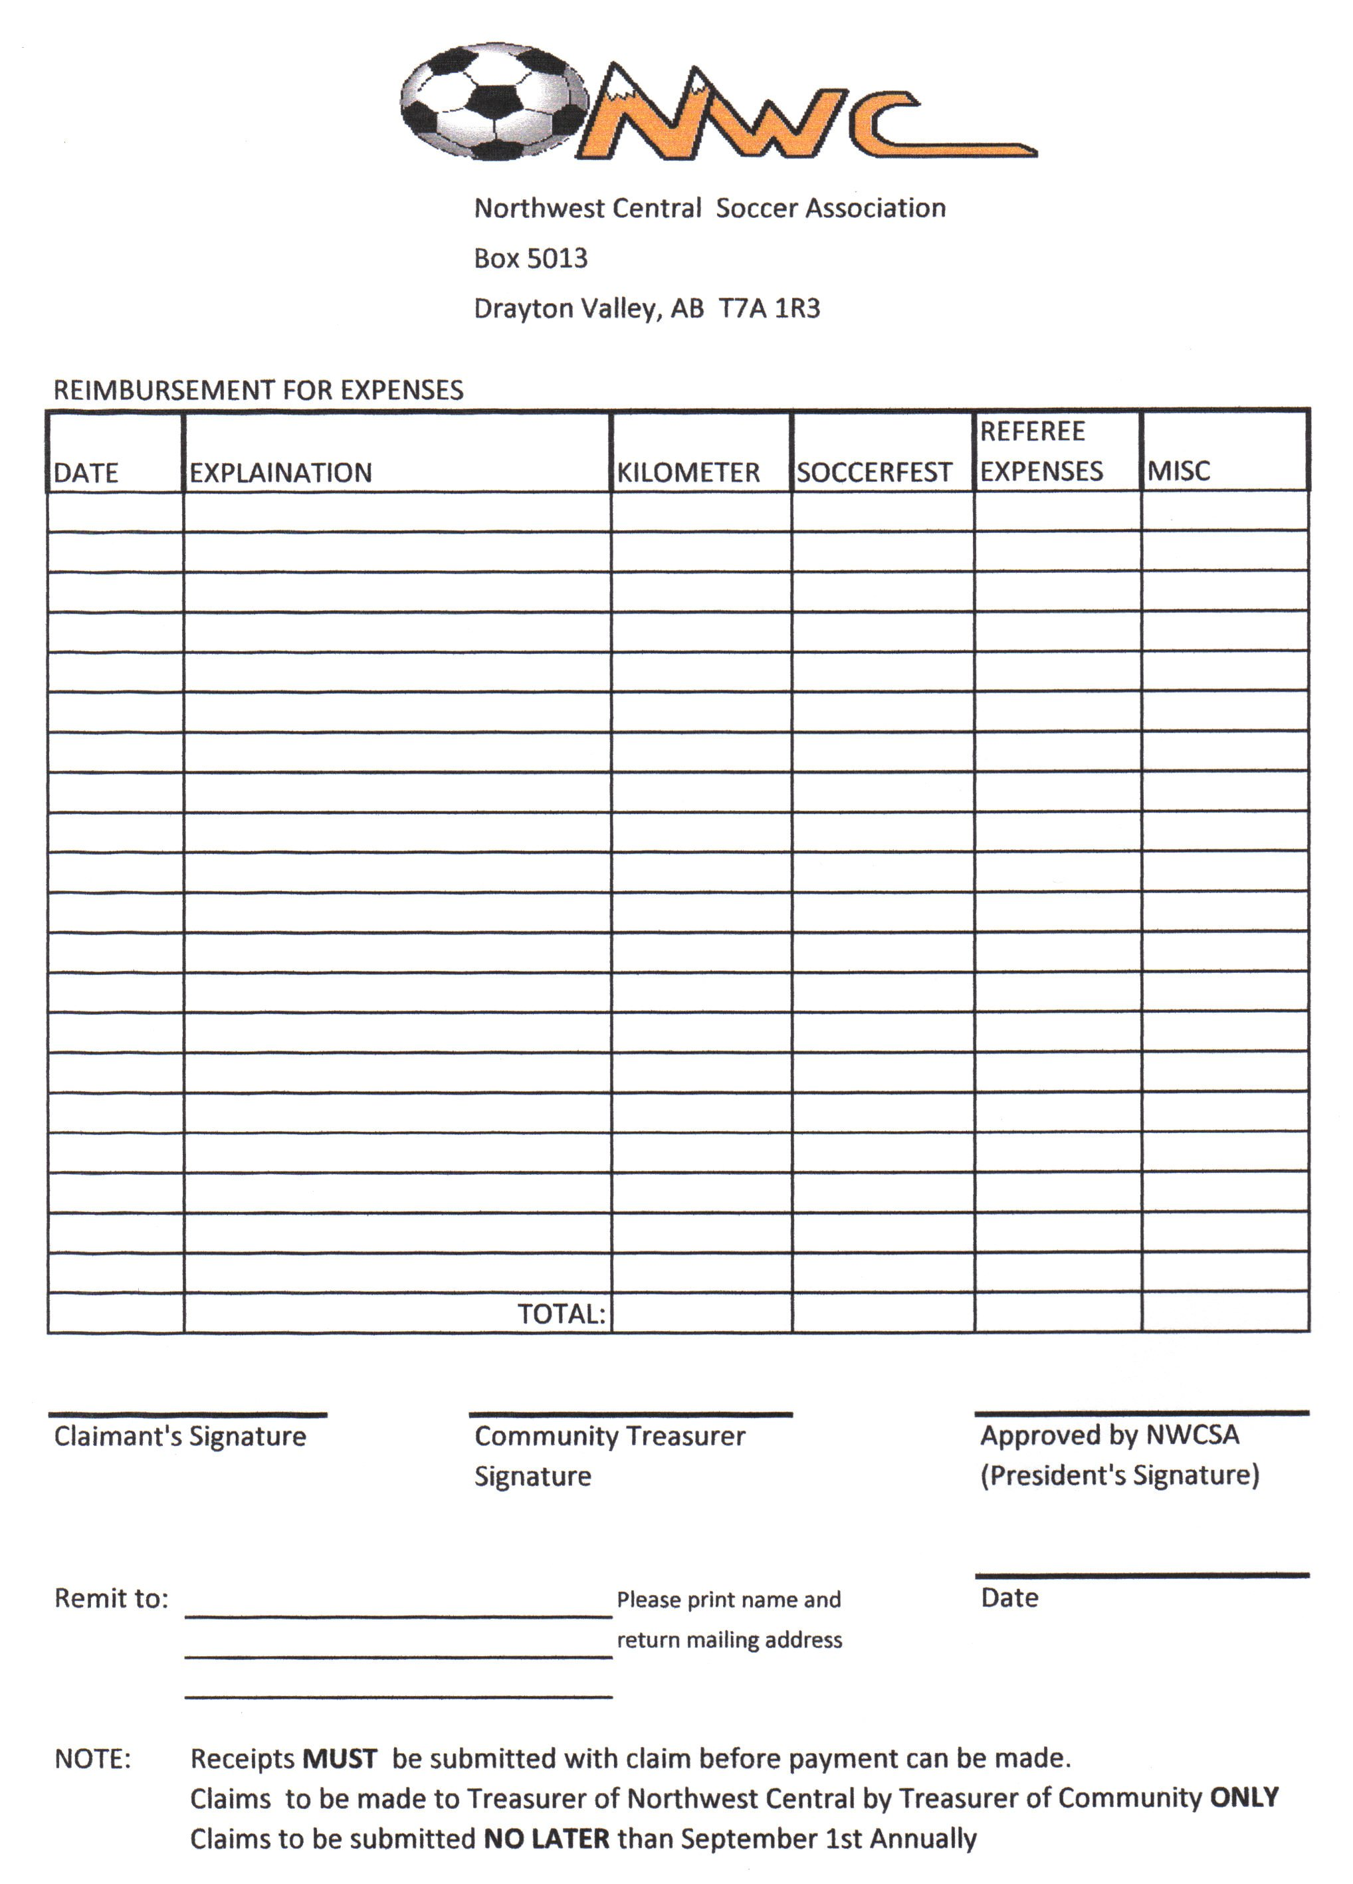
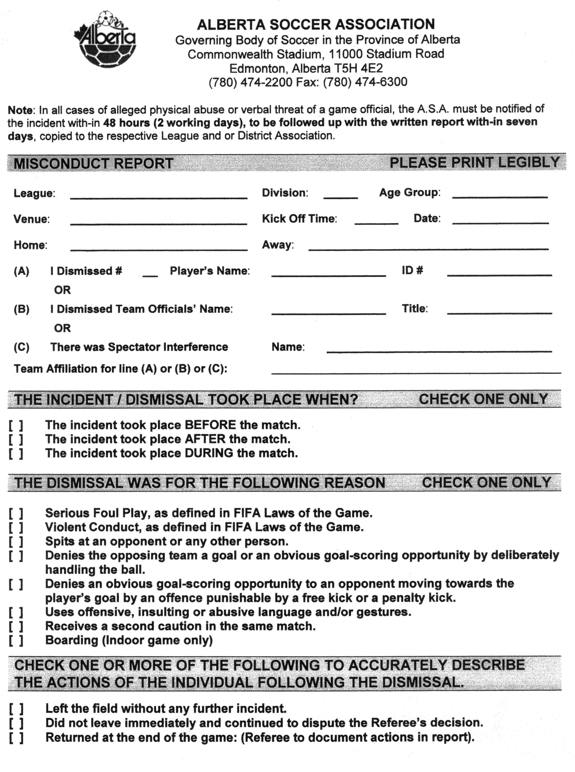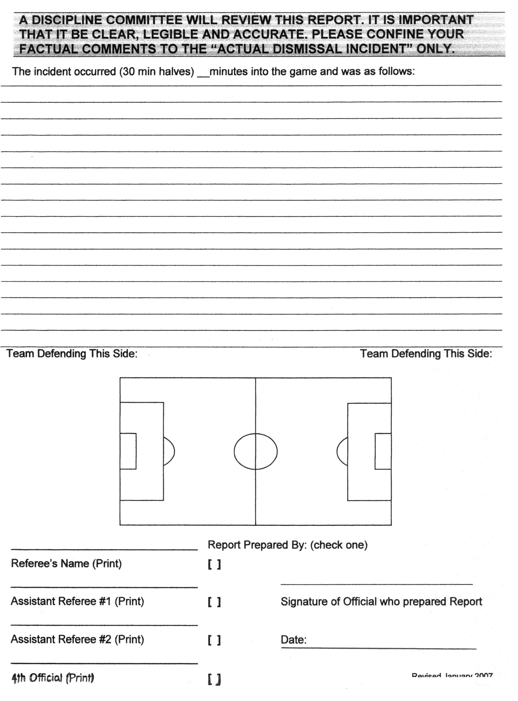
RECOMMENDATIONS FOR SOCCERFEST:

For many children this will be the best level of play that they will experience in their lifetime. The community hosting should give them the feeling of accomplishment that they have earned.

The hosting community should be prepared to do the extras:
Porta Potties, Results Board, First Aid Station or Qualified person at the field(s)
Fair Play Award (per game) – 1 player per team especially in the younger age groups
Barbeque and/or Skills Competition with prizes

Hosting communities will be reimbursed by NWCSA the following:
$30.00 per game for Fair Play awards, all officiating costs, and any expenses directly related to and necessary for hosting Soccerfest. A detailed breakdown and summary of all costs (including signed game sheets) must be submitted to the NWCSA Treasurer before payment will be made. Application for remuneration must be made to the Treasurer on a NWCSA Expense Form. Any and all payments will be at the discretion of the NWCSA Executive.

Hosting communities will use the scheduling formats set out in this booklet at all times.

A MERCY RULE OF 6 GOALS SHALL BE USED IN ALL SOCCERFEST PLAY (ALL AGE GROUPS).

FORFEITED GAMES AT SOCCERFEST WILL BE TREATED AS 3-0 WINS IN THE STANDINGS.

NOTE – A MINIMUM OF 2 HOURS BETWEEN GAMES IS REQUIRED AND A
MAXIMUM OF 2 GAMES PER DAY WILL BE PLAYED BY A TEAM

All hosting communities should have a Field Marshall in place (not a host coach). One week prior to Soccerfest, the hosting community should inform the NWCSA President and District Registrar of who the Field Marshall will be. Field Marshall duties will be to collect a completed and signed A.S.A. roster sheet, prior to the first games, from all teams competing. Coaches are to bring this sheet to the competition. The form must be signed by the Registrar. Hence the need for a coaches meeting in the morning, prior to the first game, where all teams must have representation.

Field Marshall’s should also:
- Have a copy of the updated competition rules.
- Give all coaches game sheets.
- Have the lines persons and the referees organized.
- Have on hand extra schedules.
- Receive a copy of A.S.A. sheet for each team, from the Registrar, 5 days prior to Soccerfest.
- Have a list of team contacts (with cell phones, hotel staying at, etc) for all teams for the weekend play. This is incase of a change of venue or emergency.

Immediately after the Soccerfest, all final placings should be faxed or emailed to the President and the Registrar. Who won: Gold – Silver – Bronze – 4th, etc. (This information is required in the event A.S.A. requests a second team from our district to fill a Provincial slot).

NORTHWEST CENTRAL SOCCER ASSOCIATION SOCCERFEST

UNDER _____ BOYS GIRLS YEAR _________

HOST:

FORMAT: 2 Team – 2 Game Format

SEEDING:
1.
2.

GAME | SEED | HOME | AWAY | DATE | TIME | FIELD
1. | 1 vs 2
2. | 2 vs 1

If tied after Game 2 – Go Directly to Penalty Kicks.

Medal/Trophy presentations immediately after Game 2.

FIELD LOCATION:

TOURNAMENT MEETING: (All teams are required to have a representative in attendance)
When:
Where:

NORTHWEST CENTRAL SOCCER ASSOCIATION SOCCERFEST

UNDER _____ BOYS GIRLS YEAR _________

HOST:

FORMAT: 3 Team Round Robin

SEEDING:
1.
2.
3.

GAME | SEED | HOME | AWAY | DATE | TIME | FIELD
1. | 1 vs 3
2. | 2 vs 3
3. | 1 vs 2

A.S.A. Round Robin Tie Breaking Rules shall determine Round Robin final standings.

The following was taken in part from the A.S.A. Championship Rules:
- any third game of a three team round robin that requires a result will go directly to penalty kicks.
- If three teams are tied (after goal difference, and goals scored): Each team is designated A, B or C by a random draw. Three mini-games shall be played (A vs B, B vs C, C vs A) consisting of 5 penalty kicks. All 5 penalty kicks must be taken. Three points shall be awarded for a win, one for a tie. The standings after these three mini-games shall be determined according to the usual criteria (results, goal difference, goals scored, etc).

Medal/Trophy presentations immediately after game #3

FIELD LOCATION:

TOURNAMENT MEETING: (All teams are required to have a representative in attendance)
When:
Where:

NORTHWEST CENTRAL SOCCER ASSOCIATION SOCCERFEST

UNDER _____ BOYS GIRLS YEAR _________

HOST:

FORMAT: 4 Team Round Robin Games 1 to 4 are Day 1 / Games 5 to 8 are Day 2

SEEDING:
1.
2.
3.
4.

GAME | SEED | HOME | AWAY | DATE | TIME | FIELD
1. | 1 vs 4
2. | 2 vs 3
3. | 4 vs 2
4. | 3 vs 1
5. | 3 vs 4
6. | 1 vs 2
7. | 3rd vs 4th
8. | 1st vs 2nd

Game 7: Bronze Game 8: Gold/Silver

A.S.A. Round Robin Tie Breaking Rules shall determine Round Robin final standings

Medal/Trophy presentations immediately after game #8

FIELD LOCATION:

TOURNAMENT MEETING: (All teams are required to have a representative in attendance)
When:
Where:

NORTHWEST CENTRAL SOCCER ASSOCIATION SOCCERFEST

UNDER _____ BOYS GIRLS YEAR _________

HOST:

FORMAT: 5 Team Round Robin Game 1 to 5 are Day 1 / Games 6 to 10 are Day 2

SEEDING:
1.
2.
3.
4.
5.

GAME | SEED | HOME | AWAY | DATE | TIME | FIELD
1. | 1 vs 5
2. | 2 vs 4
3. | 5 vs 2
4. | 3 vs 4
5. | 1 vs 3
6. | 4 vs 5
7. | 2 vs 3
8 | 1 vs 4
9. | 3 vs 5
10 | 1 vs 2

A.S.A. Round Robin Tie Breaking Rules shall determine Round Robin final standings

Medal/Trophy presentations immediately after game #10

FIELD LOCATION:

TOURNAMENT MEETING: (All teams are required to have a representative in attendance)
When:
Where:

NORTHWEST CENTRAL SOCCER ASSOCIATION SOCCERFEST

UNDER _____ BOYS GIRLS YEAR _________

HOST:

FORMAT: 6 Team Round Robin Games 1 to 6 are Day 1 / Games 7 to 11 are Day 2
(Two groups of three with crossovers)

SEEDING:
1. 4.
2. 5.
3. 6.

GROUP I (Seeds #1, 4, 5) GROUP II (Seeds #2, 3, 6)

1. 2.
4. 3.
5. 6.

GAME SEED HOME AWAY DATE TIME FIELD
1. 5 vs 1
2. 6 vs 2
3. 4 vs 5
4. 3 vs 6
5. 1 vs 4
6. 2 vs 3
7. 1st Group I vs 2nd Group II
8. 1st Group II vs 2nd Group I
9. Consolation Game
10. Bronze Medal Game
11. Gold/Silver Medal Game

A.S.A. Round Robin Tie Breaking Rules shall determine all Round Robin final standings.

Final Medal Games
Game #9 3rd Place Group I vs 3rd Place Group #II (Consolation Game)

Game #10 Loser Game 7 vs Loser Game 8 (Bronze Medal Game)
Game #11 Winner Game 7 vs Winner Game 8 (Gold/Silver Medal Game)

Medal/Trophy presentations immediately after game #11

FIELD LOCATION:

TOURNAMENT MEETING: (All teams are required to have a representative in attendance)
When:
Where:

NORTHWEST CENTRAL SOCCER ASSOCIATION SOCCERFEST

UNDER _____ BOYS GIRLS YEAR _________

HOST:

FORMAT: 7 Team Round Robin
(One group of four, one group of three with crossovers)

SEEDING:
1. 5.
2. 6.
3. 7.
4.
GROUP I (Seeds #1, 4, 6, 7) GROUP II (Seeds #2, 3, 5)

1. 2.
4. 3.
6. 5.
7.

GAME SEED HOME AWAY DATE TIME FIELD
1. 7 vs 1
2. 5 vs 2
3. 6 vs 4
4. #3 has bye
5. 1 vs 6
6. 3 vs 5
7. 4 vs 7
8. #2 has bye
9. 1 vs 4
10. 2 vs 3
11. 6 vs 7
12. #5 has bye
13. Bronze/4th 2nd Place Group I 2nd Place Group II
14. Gold/Silver 1st Place Group I 1st Place Group II

A.S.A. Round Robin Tie Breaking Rules shall determine all Round Robin final standings.

Final Medal Games
Game #13 2nd Place Group I vs 2nd Place Group II (Bronze Medal Game)
Game #14 1st Place Group I vs First Place Group II (Gold/Silver Medal Game)
Medal/Trophy presentations immediately after game #14

FIELD LOCATION:

TOURNAMENT MEETING: (All teams are required to have a representative in attendance)
When:
Where:

NORTHWEST CENTRAL SOCCER ASSOCIATION SOCCERFEST

UNDER _____ BOYS GIRLS YEAR _________

HOST:

FORMAT: 8 Team Round Robin
(Two groups of four with crossovers)

SEEDING:
1. 5.
2. 6.
3. 7.
4. 8.
GROUP I (Seeds #1, 4, 5, 8) GROUP II (Seeds #2, 3, 6, 7)

1. 2.
4. 3.
5. 6.
8. 7.

GAME SEED HOME AWAY DATE TIME FIELD
1. 8 vs 1
2. 4 vs 5
3. 7 vs 2
4. 3 vs 6
5. 1 vs 5
6. 4 vs 8
7. 2 vs 6
8. 3 vs 7
9. 5 vs 8
10. 6 vs 7
11. 1 vs 4
12. 2 vs 3
13. Bronze/4th 2nd Place Group I 2nd Place Group II
14. Gold/Silver 1st Place Group I 1st Place Group II

Consolation Games:
15. 5th vs 6th 3rd Place Group I 3rd Place Group II
16. 7th vs 8th 4th Place Group I 4th Place Group II

A.S.A. Round Robin Tie Breaking Rules shall determine all Round Robin final standings.
Medal/Trophy presentations immediately after game #14

FIELD LOCATION:

TOURNAMENT MEETING: (All teams are required to have a representative in attendance)
When:
Where:
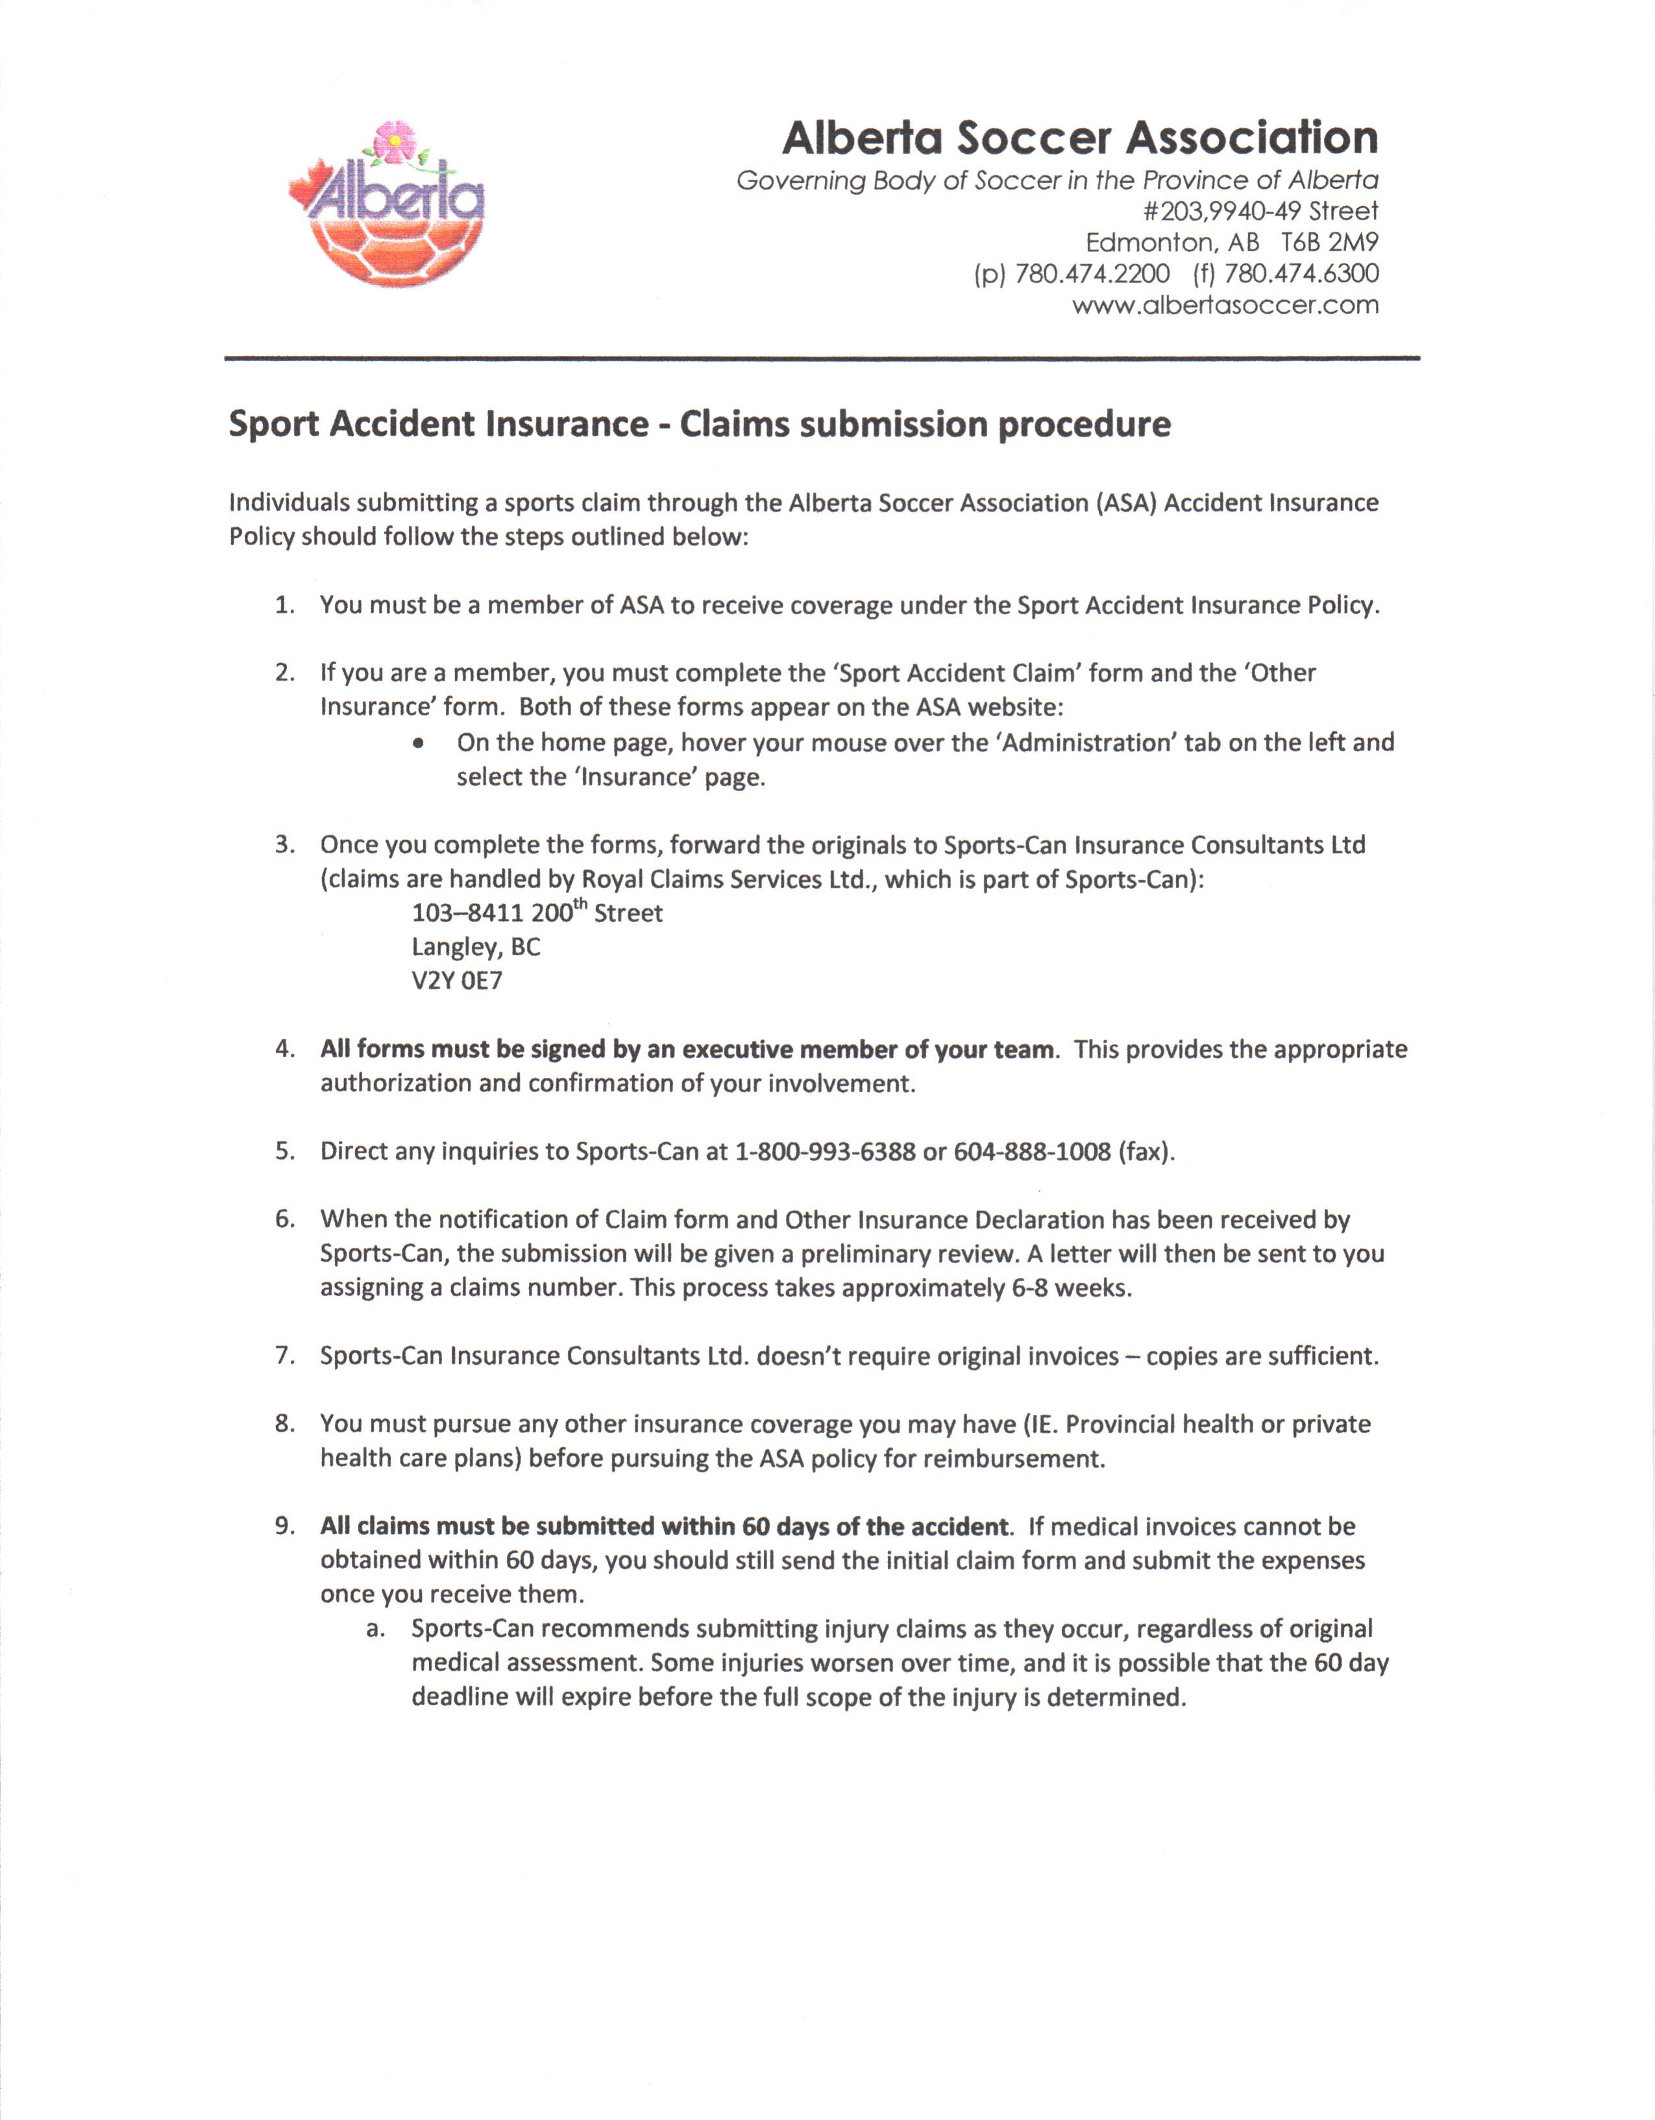
(the “Sport Accident Claim” and “Other Insurance” forms are attached as pages 28 and 29 below)


