GAME SHEET INSTRUCTIONS

Prior to October 13, 2018 All Teams must enter from Admin Login (from EIYSA Website) and enter the following in order to print game sheets.

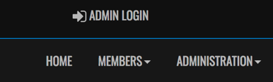

Enter Login:
Password:

One-time only entry

Dashboard
League Players:
Add Your Players Jersey # Click Edit Enter Jersey # Click Submit
Blue Button is Edit
Staff Members:
Add your Team Staff
If you do not want your name or email showing on the website Click Hide on Website & Hide Contact Info on Website. If you want your name but not your email showing on website only click Hide Contact Info on Website box.

HOW TO PRINT YOUR GAME SHEET

From the Dashboard Click League Games- find current game (can be sorted by date and game type)

Click Print Icon for the game to be played

Print off the game sheet.

Manually Cross off those players not playing that game.
Manually Add any Trialists
Manually Fill out Team Staff (ID# on the Team Officials Card)
Manually Fill out Referee Liaison

Give Game sheet to the Away Team (in the dressing room) so they can:
Manually Cross off those players not playing the game
Manually Fill out Team Staff
Manually Fill out Referee Liaison

Home team ensures Referee receives completed Hard copy Game sheet prior to start of game.

POST GAME INSTRUCTIONS & SCORING GAMES

Home Team – Signs Game Sheet
Away Team – Signs Game Sheet

Home Team within 24 hours Must do the following:
(this can all be done from your phone at the end of the game):

Sign back in with Admin Login from EIYSA website
From Dashboard Click League Games
Click edit button [ (green pencil) only available for the home team]
Enter the Score (U9, U10 & U11 enter 0-0) U12 There is a mercy rule which is a 5 Goal Differential. (Example 6-0 game you would enter 5-0.)

Click Game is Finished – keep scrolling down

Roster

Update your Roster- if all players played click top box beside Jersey this will automatically select all players. Then you can click off those players who were manually crossed off the game sheet. This must be done by the Home Team for Home and Away. Ensure you Click Update Roster

Game Files

This is how you will submit game sheets to the office.

Upload File: Click Choose File - Take photo of game sheet (make sure to capture the entire game sheet in the Photo). Click Upload File. You can also take a picture save it and then browse and upload the game sheet.
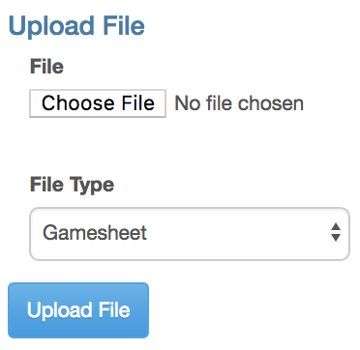
Home Team is finished you can log out.

Away Team: Sign in with Admin Login from EIYSA website – within 24 hours of the game played

Once the score is entered from the Home Team the Away Team must Verify. (Orange icon) Change Verification Status to “Verified “if score is correct or “There are errors.” Add a note addressing any Errors, remember to click “Save Note”. Click Update Verification Status.
Errors will be corrected in the office.

