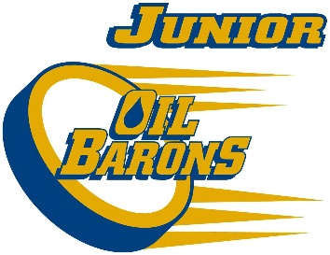
2017/18 Atom Development Junior Oil Barons Top 30 & 4 Goalies
Kyle Anderson
Gavin Arsenault
Connor Blackwood
Blaize Bouchier
Landon Bourque
Dawson Butler
Nathan Carter
Jacob Elliott
Graeme Galloway
Thomas George
Brayden Gray
Liam Holland
Brendan Hurley
Austin Hutchinson
Jayden Jenkins
Jesse Kenny
Chayse King
Brayden Lacorde
Gavin Mckay
Blake Meyer
Kaleb Morrison
Ethan Pittman
Andrew Power
Declan Roberts
Jackson Schreyer
Brody Seymour
Parker Seymour
Keegan Shott
Mike Szpak
Miguel Tetreault
Goalies
Parker Flett
Griffin Gratton
Nolan Knox
Andrew Pellegrino
The above mentioned players will move onto the next ice time, Sunday Sept 10th 2:45-4:00pm Frank Lacroix.

