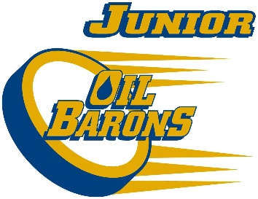
2017/18 Atom Development Junior Oil Barons Final Roster
Gavin Arsenault
Connor Blackwood
Blaize Bouchier
Landon Bourque
Dawson Butler
Jacob Elliott
Graeme Galloway
Thomas George
Jayden Jenkins
Jesse Kenny
Chayse King
Ethan Pittman
Brody Seymour
Parker Seymour
Mike Szpak
Griffon Gratton
Parker Flett
The above mentioned players are to attend below:
Wednesday September 20th 5:30-6:30 at Frank Lacroix

