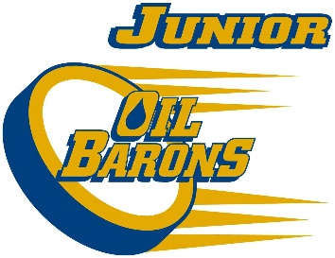
2017/18 Peewee AA Junior Oil Barons Final Roster

Forwards:
Riley Banfield
Coen green
Colin Hanhart
Brendan McFatridge
Quinn Szpak
Bronson Seymour
Kayden Morrison
Mathew Noble
Carter Marshall
Brayden Vanderbiche

Defence:
Carter Simon
Jayden Shott
Brayden Rowsell
Jayden Conway
Nathan Gagne
Kyle Marsden

Goalies:
Even Norman
Lochlan Zorn

