GRANDE CACHE MINOR HOCKEY ASSOCIATION

SOCIETY BYLAWS
&

OPERATING PROCEDURES

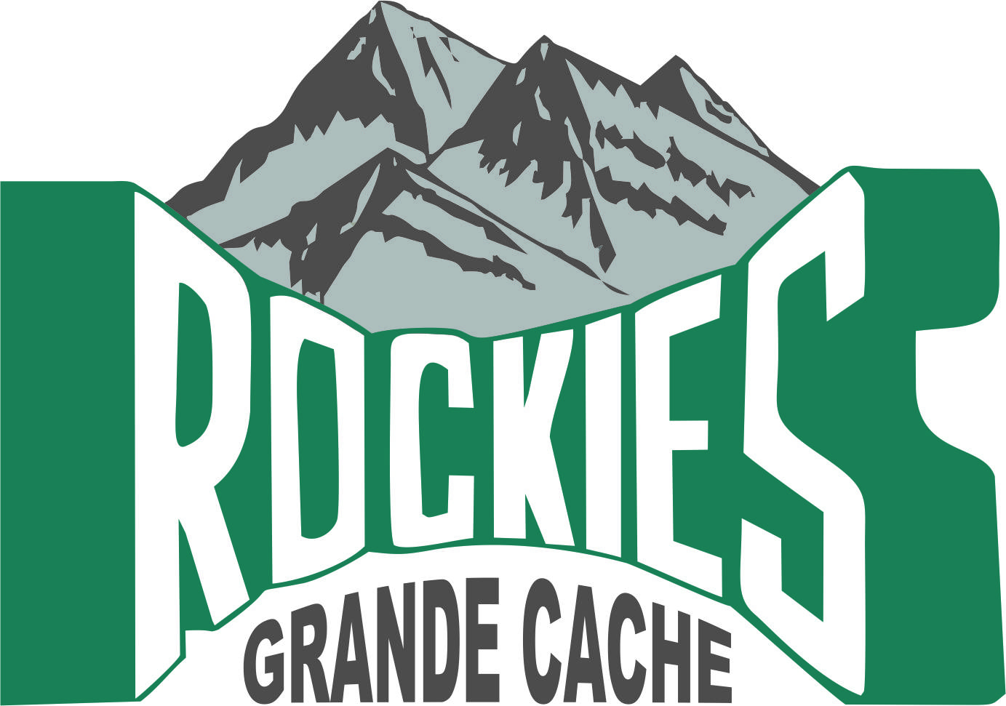

CORPORATE ACCESS # 500066377
Incorporated since 1972

Updated April 2015
Registered July 2015

GRANDE CACHE MINOR HOCKEY ASSOCIATION
SOCIETY BYLAWS AND OPERATING PROCEDURES
TABLE OF CONTENTS
BYLAWS
Bylaw 1 - Name
Bylaw 2 - Objectives
Bylaw 3- Membership
Bylaw 4 Officers
Bylaw 5 Executive
Bylaw 6 Board of Directors
Bylaw 7 Meetings
Bylaw 8 Operating Procedures
Bylaw 9 Amendments to the Bylaws
Bylaw 10 Assocation Finances
Bylaw 11 Dissolution

SOCIETY BYLAWS OF GRANDE CACHE MINOR HOCKEY ASSOCIATION
Updated April 2015
General Definitions

Where the word, "Association," or the letters "G.C.M.H.A." appear in this document, they shall be taken to mean "The Grande Cache Minor Hockey Association".

Hockey Alberta will be referred to throughout this document as "H.A."

The Canadian Hockey Association will be referred to throughout this document as the "C.H.A."

By "amateur", the Association intends the same meaning as given to the term by "H.A."

The name All Peace Hockey League will be referred to throughout this document as APHL

BYLAW ONE - NAME

The name of the organization will be the GRANDE CACHE MINOR HOCKEY ASSOCIATION.

BYLAW TWO - OBJECTIVES

It will be the primary objective of the Grande Cache Minor Hockey Association to provide a minor hockey program from Initiation to Midget divisions within the community of Grande Cache, Alberta. The GCMHA minor hockey program will be based on skill development along with the guiding principles of fair play, positive competition and respect amongst all Association members. The GCMHA will endorse and promote active participation, sportsmanship and enjoyment of hockey in all levels of play. All decisions will be tempered with reason, balance and regard for the needs of the individual and the team. It is our belief that this atmosphere will provide the greatest enjoyment and most wholesome hockey experience for all concerned.

BYLAW THREE - MEMBERSHIP

The registration fee of a player registered in the GCMHA shall include membership fees of parents or guardians.

B. The annual membership fee shall be established by the Board of Directors.

C. Any adult or player within the Grande Cache Minor Hockey Association who pays the prescribed membership fee through player registration as established annually or is voted in by another member of the GCMHA at a General and/or Special Meeting is a member of the GCMHA and may participate fully in the affairs of the GCMHA.

D. Membership will be for the current hockey season only.

E. A voting member is any parent or guardian who has paid in full their registration fees for the current hockey season.

F Any adult who holds a position on the Executive or Board of Directors of the GCMHA. for the current hockey season will have full voting privileges and is a member of the GCMHA.

Any general member or member of the Board of Directors including Team Officials can resign from the Grande Cache Minor Hockey Association by withdrawing their player registration or submitting a letter to the President of the Association.

BYLAW FOUR - OFFICERS

Nominations and Elections

Any GCMHA member may nominate another person, current or past member to fill each of the officer positions of the GCMHA and present this nomination at a General or Special Meeting, all nominations for positions of office of the GCMHA shall be voted upon.

If there are no nominations, Board members can appoint these positions and inform the membership of the appointment at a General or Special Meeting. The appointment is subject to final approval from the GCMHA Executive and Board of Directors.

3. All positions of office for the GCMHA are effective for the current hockey season only.

4. All positions of office must be voted upon annually at the spring or fall AGM.

GCMHA Positions of Office

The Executive Officers of the GCMHA shall consist of:

President

Vice-President

Secretary

Treasurer

Registrar

Past President

The Board of Directors of the GCMHA shall consist of a minimum of thirteen (13) Managers and six (6) Executive Officers. If there are two teams in one division, there will be a Division Managers for each team in that respective division.

Six Executive Officers

Manager, Initiation Division

Manager, Novice Division

Manager, Atom Division

Manager, Pee Wee Division

Manager, Bantam Division

Manager, Midget Division

Manager, Female Division

Manager, Pond Hockey

Referee - In - Chief

Director of Facilities – Ice Scheduler

Equipment Manager

Director of Fund Raising

Coach Director

If there are no nominations in any of the above positions, the newly elected Board of Directors may appoint someone to said position or positions. A Board of Director member can resign from the GCMHA Board of Directors or Executive by giving two weeks notice in writing to the Association President. In the event, the Association President wishes to resign, he or she must notify the Vice President in writing and provide a minimum two weeks notice to allow a transition period of duties to the Vice President or Past President as required.

All positions of office which includes the GCMHA Executive, Board of Directors, Team Officials (i.e. coaches and team managers etc) are volunteer positions and not paid positions.

Removal of Officers

The GCMHA Board of Directors can remove and replace any Officer considered to be acting in a manner prejudicial to the aims and objectives of the GCMHA or to be seriously neglecting his or her duties. Officers will be removed by majority vote of the Board of Directors and will be notified in writing of this decision within 2 days.

In exceptional circumstances (i.e. criminal conduct, code of conduct violation, immediate risk to members), the Association President can suspend any Officer immediately from their position by verbal notification. The President will call a Board of Directors meeting within 5 days of the suspension and present the circumstances of the suspension to the Board of Directors. The Officer can be removed by majority vote of the Board of Directors and will be notified of the final decision in writing within 2 days.

BYLAW FIVE - EXECUTIVE

Membership

The Executive shall consist of the President, Vice-President, Secretary, Treasurer, Registrar and the Past President.

Where the immediate Past President is unable or unwilling to serve on the Executive, the next most immediate past president will be appointed by the Board of Directors to serve on the Executive. Where the Past President is unavailable to serve, the Vice President shall be appointed to serve as President for the current hockey season.

Duties

The President shall:

Call and preside at all Board of Directors, Executive, General or Special meetings.

Call and preside at all discipline Committee meetings, except where he or she may be the subject of the meeting, in which case the Vice-President will call the meeting.

Call executive meetings as required to deal with emergency problems of the Association, provided that minutes of all such meetings shall be presented at the next Board of Directors meeting for ratification.

Pass rulings and judgments on any matter pertaining to the Association, provided that such rulings and judgments shall be in keeping with the objectives, bylaws and operating procedures of the GCMHA.

Act as an ex-officio member of all Committees of the GCMHA with full voting privileges.

Vote as he or she deems appropriate, but shall announce his or her intention to vote when the question is called.

Ensure the Code of Conduct is adhered to within GCMHA .

Ensure that the Association is represented and/or votes on behalf of the Association on all matters pertaining to Hockey Alberta, All Peace League and other organizations as required in consultation with the Board of Directors. A delegate may be designated by the President to act on behalf of the Association in these matters.

The Vice-President shall:

Assume the duties of the President during that officer's absence.

Monitor and ensure, along with the Director of Fundraising, the coordination of all fundraising activities in order that the priorities of the Board of Directors are provided for.

Monitor and ensure, along with the Coach Director, that all GCMHA coaching staff receives the necessary training as required Hockey Alberta bylaws and regulations

Attend all Discipline Committee Meetings, except where he or she may be the subject of that meeting.

Ensure the Code of Conduct is adhered to within GCMHA.

3. The Past President may:

a) attend and participate in meetings of the Executive, Board of Directors, Special or General meetings.

At the request of the Board of Directors, where both the President and Vice-President are unable to act for the GCMHA and it appears imperative that someone makes a ruling or judgment for the Association, act in the place of the President, on behalf of the GCMHA.

A request could be made by either the President or Vice-President to have the Past President provide a recommendation based on their historical experience and knowledge on matters before GCMHA.

4. The Secretary shall:

Keep records and minutes of all meetings of the Executive, the Discipline Committee, Board of Directors, Special and General Meetings.

Prepare and present an agenda prior to each meeting.

Circulate minutes of all meetings to the Board of Directors and Members as requested.

Prepare correspondence as requested for Association business.

Keep records of changes to the GCMHA Bylaws and Operating Procedures Manual.

5. The Treasurer shall:

Collect, or arrange for the collection of all fees and dues from the Registrar.

Record and deposit all Association revenues.

Keep accurate accounts of all Association expenditures.

Deliver a monthly financial report to the Board of Directors.

A year end report shall be presented to the members of the GCMHA at the Spring Annual General Meeting of the GCMHA.

Deliver to the membership during the Fall Annual General Meeting a draft budget as approved by the Board of Directors.

Have the Associations books audited annually, according to the instructions of the Board of Directors.

Provide financial reports to any member of the GCMHA within seven (7) days of written request to the Executive.

6. Signing Officers:

The signing officers for the GCMHA shall be the Treasurer, and either the President or Vice-President.

BYLAW SIX - BOARD OF DIRECTORS

The Board of Directors

The Board of Directors shall:

a) Consist of the Executive and Board of Directors as defined in this policy.

Conduct the business of the Association in its entirety in accordance with the Bylaws, Operating Procedures and objectives of the Association.

Ensure that all personnel of the Association exercise fair and sportsman-like conduct in promoting the game of hockey for players and for the Association. The Board may take any action necessary to encourage and promote this policy.

Remove and replace any Member considered to be acting in a manner prejudicial to the aims and objectives of the GCMHA or to be seriously neglecting his or her duties, provided that such action is in the form of a motion supported by a 2/3 majority of the GCMHA Board Members.

Replace any member of the Board who misses three consecutive regular meetings without adequate reason or who resigns.

B. Manager of Each Hockey Division

The Manager shall:

Attend all meetings of the Board of Directors, Discipline Committee meetings, which pertain to his or her division and Special and/or General Meetings.

Act as liaison between his or her division and the Board of Directors.

Ensure that his or her division operates according to the aims and objectives of the GCMHA.

Host a team meeting at the start of the hockey season, advise members that the Bylaws and Operating Procedures of the GCMHA can be found on the Grande Cache Minor Hockey website.
      - Ensure that all players, via communication from the Registrar, are registered and Team Officials are certified and approved prior to going on the ice or engage in Minor Hockey activities.

Ensure that any changes to the team roster or player status are registered with local registrar to update within the HA & APL league.

Ensure that procedures as outlined in the Managers Manual are adhered to.
      - Provide a report that summarizes your season, for his or her division at the Annual Spring General meeting.

C. Referee in Chief

The Referee in Chief shall:

Determine and/or approve procedures to be followed in assigning officials so that all officials will have an equitable opportunity to officiate games in levels where they are competent.

Be responsible to ensure a satisfactory method of payment of officials.

Act as liaison between the GCMHA and all referees in Grande Cache.

Be responsible for the organization of the referee's clinic each season and to ensure that all referees are certified through HA.

Attend meetings as required each season with Team Officials, Division Directors and players to update them on rule changes, etc.

D. The Director of Facilities (Ice Scheduler)

The Director of Facilities shall:

Be responsible to schedule all ice times for the GCMHA games and practices.

Arrange seasonal ice schedule; age appropriate for all teams.

Reserve and/or schedule all local facility bookings.

Work in cooperation with other groups using the ice surface to ensure the GCMHA is properly represented.

Represent GCMHA at Ice Scheduler annual APL meeting.

Maintain accurate icetime records for the purposes of billing confirmation.

Director of Fund Raising

The Director of Fund Raising shall:

The Director of Fundraising will report to the Board of Directors all fundraising activities for the hockey season.

All fund raising activities are subject to approval by the Board of Directors.

To make sure that fundraising and reporting is done in accordance with ALGC guidelines and regulations.

Ensure SOCAN reporting is done as required.

Act as Raffle Chairperson for GCMHA.

Oversee annual player and team picture event.

Registrar

The Registrar shall:

Take the necessary steps to ensure that all GCMHA team registrations, player registrations, player affiliations, over age applications and team officials are completed accurately in accordance with Hockey AB regulations and submit the appropriate documentation to HA within the specified time frames.

Ensure that any changes to a player's status are submitted in accordance with HA Regulations and timeframes.

Arrange for the collection of all registration fees and dues for submission to the GCMHA Treasurer.

Coach Director

The Coach Director shall:

Work with the Vice President to ensure that all GCMHA coaching staff receives the necessary training as required by Hockey Alberta

Recommend training and development clinics for the betterment of hockey within the GCMHA.

Work as a liaison between the GCMHA Coaches and GCMHA Executive and Board of Directors

Attend coach discipline committee meetings except where he or she may be the subject of that meeting

Work with the Executive and consult the Executive on matters pertaining to player movement, team and coach selection in accordance with GCMHA Bylaws and Operating Procedures
Ensure the Code of Conduct is adhered to within GCMHA

BYLAW SEVEN – MEETINGS

Meetings required by the membership of the GCMHA General and Special Meetings

One Annual General Meeting will be held with the membership of the GCMHA each year at the end of the hockey season.

Annual General Meetings or a Special Meeting must be advertised 21 days prior to the date of the meeting.

A quorum for a General or Special meeting shall consist of a minimum of 15 members from the GCMHA.

General and Special meetings shall be conducted according to Robert's Rules of order (Revised).

Special Resolutions can only be passed at a Special and/or General meeting. A minimum of 75% of the membership present must vote in favor of a Special Resolution.

Members can vote at a General or Special meeting in person by a show of hands and/or ballot.

Vote by Proxy

Each member is allowed one vote however a member who cannot attend a General or Special meeting for valid reasons can vote by proxy (have someone vote on their behalf) provided the member informs the Association President and/or Secretary in advance of the meeting. This Proxy will be recorded in the minutes of that meeting. No Votes will not be accepted after a final vote has been conducted at a General or Special meeting.

Board of Directors Meetings

1. The Board of Directors must meet at least once per month during the hockey season.

Any member of the Board of Directors may call a meeting to deal with specific issues. The President shall call a meeting with the affected parties within 5 days of receiving the notice.

A quorum for the Board of Directors shall be a simple majority of all members of the Board.

Meetings of the Board of Directors shall be open to the membership however:

Directors and Members of the Executive will be the only ones permitted to vote at these meetings.

A member will be invited to address the Board when they have business that has been added to the approved agenda.

Executive Meetings

The President may call meetings of the Executive as required to deal with urgent business of the Association.

The minutes of all Executive Meetings shall be presented to the next Board of Directors Meeting.

D. Discipline Committee Meetings

1 The President shall call Discipline Committee meetings in conjunction with the GCMHA Independent Chairman as required according to the terms set forth in the GCMHA Code of Conduct.

BYLAW EIGHT - OPERATING PROCEDURES

Establishment of and Amendment to Policy

1 . The Board of Directors shall establish and maintain Operating Procedures to govern the day-to-day operations of the Grande Cache Minor Hockey Association.

Policy and regulations included in the Operating Procedures may only be changed by a 2/3 majority vote of the total Board of Directors.

In establishing Operating Procedures, the Board of Directors shall consider carefully the GCMHA objectives and wishes of the members as expressed by the membership at a General or Special Meeting or written format and report any changes in procedures to the membership at the next General or Special Meeting.

4. Operating Procedures must be in compliance with Hockey Alberta rule and regulations governing Minor Hockey.

B. C ontents of the Operating Procedures:

The Operating Procedures of the G.C.M.H.A. shall contain the Association Operating Procedures with respect to:

Registration and Fees

Structure of the GCMHA

Team Selection

Player Movement

Overage Players

Affiliation

Association Finances

Team Finances and Fundraising

Initiation and Novice Tournaments

GCMHA Tournaments

Game Officials

Game Rules

Discipline Committee & Code of Conduct

Drug Policy

Uniforms & Equipment

Awards

Volunteers

Distribution of Bylaws and Orientation

Manager Manuals

BYLAW NINE - AMENDMENTS TO BYLAWS OF THE ASSOCIATION

The BYLAWS of the GCMHA shall be as follows:

The bylaws of the GCMHA shall be enforced with reference to the provisions of the Societies Act of the Province of Alberta and terms used in these bylaws shall be taken as having the same respective meaning as they have when used in that Act.

The bylaws of the Association shall not be amended or added to except by Special Resolution of the members of the GCMHA as defined in Section 1(d) of the Societies Act.

Special Resolution of the GCMHA Society Bylaws or Objectives shall only be conducted at a General and/or Special meeting of the GCMHA.

GCMHA shall advertise notice of a meeting 21 days prior to the date of meeting.

Written notice for amending the bylaws by Special Resolution must be submitted to the Secretary of the Association no later than (1) week before the date of the meeting.

A minimum of 75% of the members in attendance must vote in favor of a Special Resolution.

All amendments to the Bylaws or Objectives of the GCMHA by way of Special Resolution must be filed with Corporate Registries of Alberta within 30 days of General and/or Special meeting.

BYLAW TEN ASSOCIATION FINANCES

The Association shall maintain a permanent and accurate record of all Association revenues, assets and expenses.

The GCMHA Treasurer and President of the Association in consultation with the Board of Directors will establish a budget at the beginning of the hockey season. This budget must be voted in by the Board of Directors and presented to the membership at a General and/or Special meeting.

The Treasurer must deliver a monthly financial report to the Board of Directors and a year end Financial Report to the members of the GCMHA at the Spring Annual General Meeting.

The GCMHA will have the Associations’ books audited annually at the end of the Association fiscal year as approved by the Board of Directors.

The GCMHA fiscal year shall be from May 1 to April 30.

The GCMHA will not borrow money at any time. All revenue will be received from player registration fees and approved fund raising venues by the Board of Directors and GCMHA membership.

The GCMHA may allow a member of the G.C.M.H.A. to examine the Association’s financial records within seven (7) days of written request to the GCMHA Executive at a General or Special meeting or designated area approved by the Executive.

BYLAW 11- - DISSOLUTION

In the event that the Grande Cache Minor Hockey Association should be dissolved by a 2/3 majority vote of those members present at a General or Special meeting, the Board of Directors will prepare a plan for distributing all funds and assets among deserving sports organizations within Grande Cache. This plan will be presented, amended as required and ratified at a final General and/or Special Meeting called for that purpose whereupon the Board of Directors shall resign and cease to represent and act for the Grande Cache Minor Hockey Association.

