CCMI – Sports Association Website Page & Copy

The Grande Prairie Minor Hockey Association is committed to protecting the health and safety of our athletes. Although we strive to prevent concussions, the reality is they are part of the game. As a result, we have partnered with Complete Concussion Management Inc. (CCMI), a Canadian-based, international research and concussion care organization. From initial pre-season baseline testing to concussion treatment and rehabilitation, CCMI practitioners are trained to provide standardized healthcare solutions to effectively manage concussions, and ensure athletes safely Return to Learn, Work and Play.

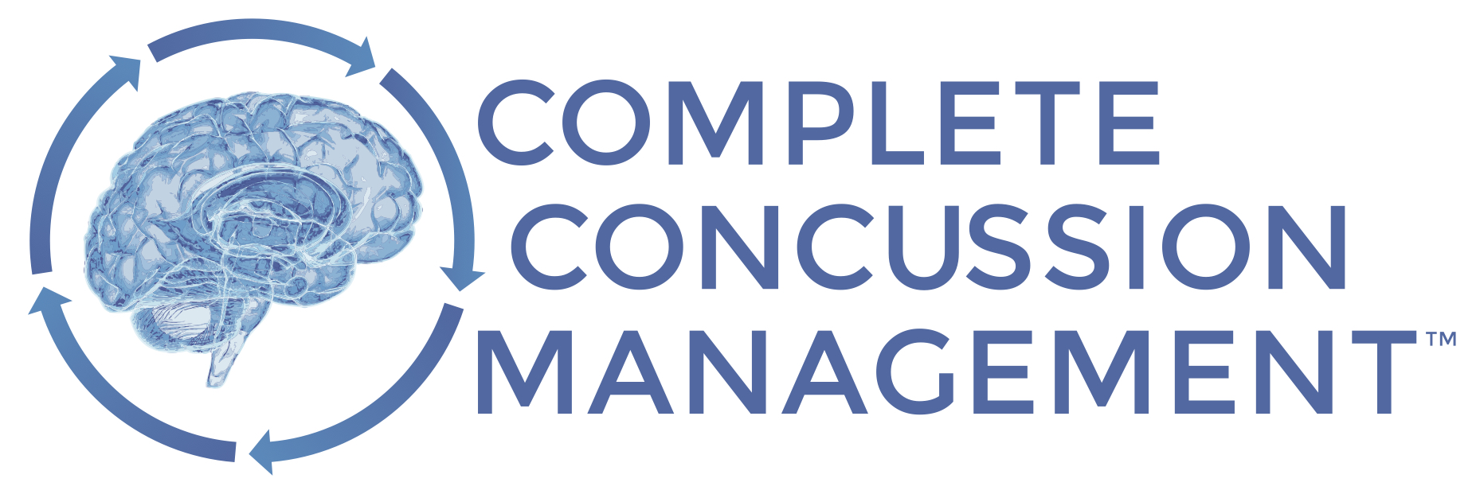

What is a concussion?
A concussion is a brain injury caused by acceleration or deceleration of the brain following a significant impact to the head or elsewhere on the body. The impact causes biochemical imbalances within brain cells, resulting in decreased blood flow and temporary energy deficits within the brain. Symptoms may include loss of consciousness, headache, pressure in the head, neck pain, nausea or vomiting, dizziness, or balance problems, among others.

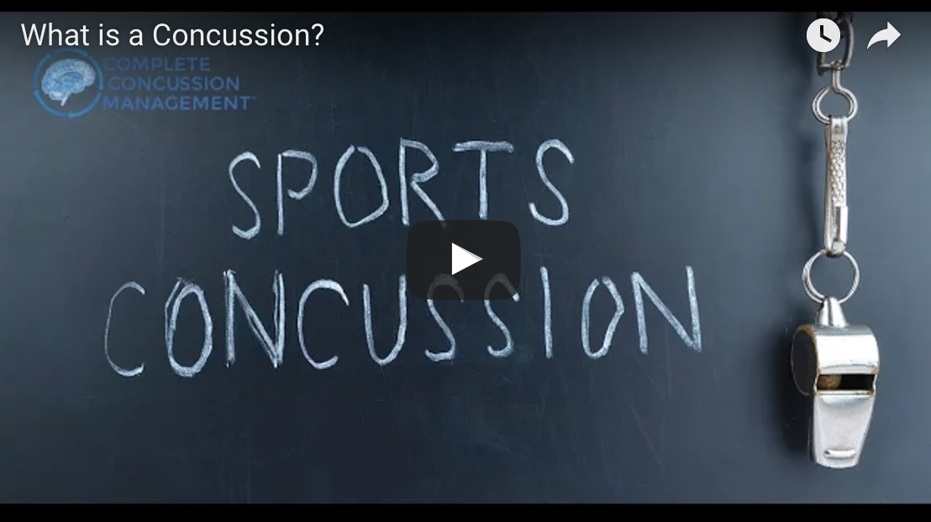

Baseline Testing

Baseline testing is a series of physical and cognitive tests that provide a pre-injury overview of healthy brain function. These tests can offer healthcare practitioners with an objective benchmark on which to compare should an athlete sustain a concussion.

As concussion symptoms often disappear days to weeks before the brain has recovered, having valuable baseline information may help healthcare practitioners to make safer return to play decisions.

As part of our partnership with CCMI, Grande Prairie Minor Hockey Association encourages baseline testing for our athletes. For more information about baseline testing click here.

Concussion Treatment

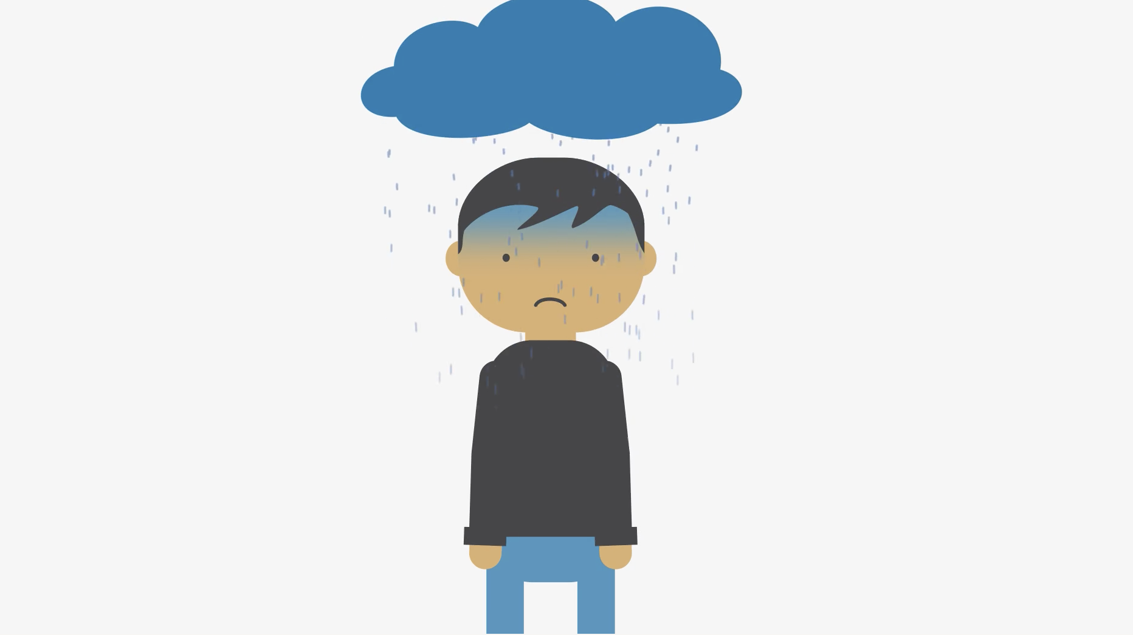

During the early stages following injury, moderate, symptom-limited rest is recommended. CCMI generally recommends 24 to 48 hours; however, these decisions are made on a case-by-case basis.

Following a short period of rest, treatment may include a gradual increase in mental and physical activity. If symptoms persist beyond 10 days, exercise therapy; manual therapy of the neck; diet and nutrition changes; and vestibular and visual rehabilitation are proven to be most effective. The international concussion consensus recommends seeking the care of a trained and experienced concussion practitioner if symptoms persist beyond 10 days. Visit completeconcussions.com to find a recognized healthcare provider.

Return to Learn, Work and Play

Standardized concussion treatment and Return to Learn, Work, and Play strategies allow healthcare practitioners to safely manage these injuries, ensuring adequate recovery time, and thereby limiting the risk of further injury.

The CCMI 10-step process includes a phased return to cognitive and physical activity:

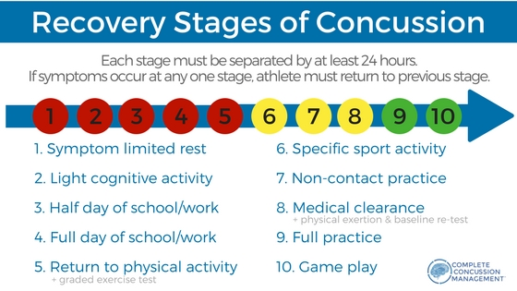

Concussion Sideline Course
Moving forward, our coaches and trainers will complete the Concussion Sideline Course, equipping them with an understanding of what a concussion is, how to recognize them, and how to assist in safely managing a concussed athlete back into the classroom and sporting environment.

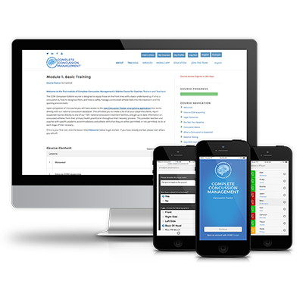

Coaches and trainers will also receive access to the mobile Concussion Tracker App, allowing them to assess and report suspected concussions to recognized CCMI clinics as well as track recovery status on injured athletes. This allows seamless communication between teams and healthcare practitioners and ensures safe return to learn, work and play. Patients tested and treated through a CCMI clinic can also access their health records at any location.

Why Complete Concussion Management?

CCMI develops evidence-based concussion training programs for multi-disciplinary teams to improve the management of concussions. All recognized CCMI practitioners are regularly updated on current research and treatment protocols, offering best-in-class approaches to concussion care. The CCMI network provides a standardized program and access to your baseline and concussion health records at any location. For more information, visit www.completeconcussions.com.

To view the Grande Prairie Minor Hockey Association Concussion Policy, developed in partnership with CCMI, please click below:

Concussion Quick Facts
- Helmets and mouth guards do not protect or reduce the risk of concussion
- 90% of concussions do not result in loss of consciousness
- MRI and other diagnostic scans show structural damage in the brain, and do not identify energy deficits caused by concussion
- Symptoms of concussion typically go away in 7 – 10 days; however, the actual recovery of the brain can take much longer

