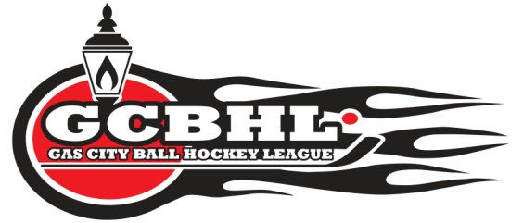
COACHING APPLICATION
FOR 2018 SEASON
Name: _____________________________________________________________
Home Phone: ______________________ Cell Phone: ______________________
E-Mail Address: _____________________________________________________

I WOULD LIKE TO BE CONSIDERED A COACH FOR THE FOLLOWING AGE GROUP:

Peanut Blaster Crusader Avenger Minor Major
HEAD COACH ASSISTANT COACH

PREVIOUS COACHING EXPERIENCE
Ball Hockey: ( )yrs Ice Hockey: ( )yrs Soccer: ( )yrs Other: ____________________ ( )yrs
“SPEAK OUT” CERTIFIED YES NO
COACH CERTIFICATION: Level 1 Level 2 Level 3

COACH’S CODE OF CONDUCT:
I, _________________________ agree that the GCBHL is a competitive, recreational, NON – CONTACT league to be enjoyed by boys and girls. As indicated by my signature, I will ensure FAIR PLAY and FUN for everyone while developing skill, teamwork, and sportsmanship.
______________________ ____________________
Signature Date

