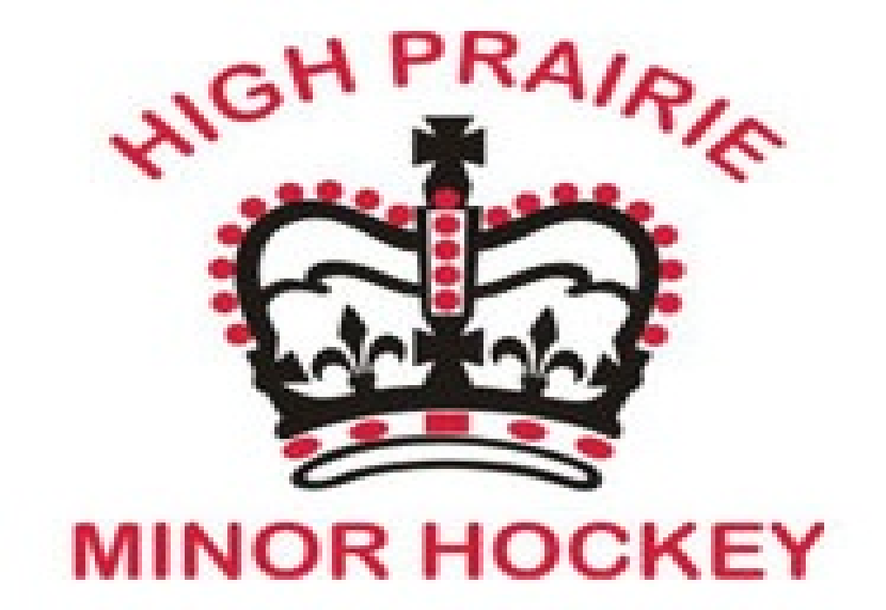
MINOR HOCKEY EQUIPMENT
CHECKLIST

Player:
______ Skates
______ Stick
______ Tape
______ Helmet with Mask
______ Neck Guard
______ Shoulder Pads/Chest Protector
______ Elbow Pads
______ Gloves
______ Hockey Pants
______ Shin Guards
______ Hockey Jock/Jill
______ Equipment Bag
______ Practice Jersey
______ Practice Socks
______ Name Bar x 2 (Can be ordered & purchased from The Promo Store)
______ Long John Underwear (Optional)
______ Mouth Guard (Optional)

Goalie:
______ Goalie Skates
______ Goalie Stick
______ Tape
______ Goalie Helmet
______ Neck Guard
______ Blocker
______ Catcher
______ Chest Protector
______ Hockey Pants
______ Goalie Pads
______ Hockey Jock/Jill
______ Equipment Bag
______ Practice Jersey
______ Practice Socks
______ Name Bar x 2 (Can be ordered & purchased from The Promo Store)
______ Long John Underwear (Optional)
______ Mouth Guard (Optional)

