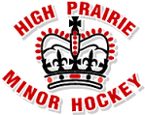
POND HOCKEY EQUIPMENT
CHECKLIST

______ Skates
______ Stick
______ Tape
______ Helmet with Mask
______ Neck Guard
______ Shoulder Pads/Chest Protector
______ Elbow Pads
______ Gloves
______ Hockey Pants
______ Shin Guards
______ Hockey Jock/Jill
______ Equipment Bag
______ Practice Jersey
______ Practice Socks
______ Long John Underwear (Optional)
______ Mouth Guard (Optional)

