2018 / 2019 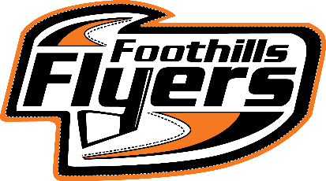 INITIATION
TOURNAMENT REGISTRATION
SATURDAY NOVEMBER 10th, 2018
Cheques ($350) can be made payable to:
FMHA Initiation Jamboree
2145 High Country Rise NW
High River, AB T1V 0E1

Registration forms can be emailed or mailed. Once your registration has been submitted, cheques must be sent as soon as possible, as registration will only be considered complete once the cheque has been received. Registration will close on October 27th, 2018. We will email with confirmation of completed registration.

Jamboree acceptance will be in order of received completed registration and Jamboree fee received. We thank you in advance.

Team Information
Minor Hockey Association Name
Team Name
Team Colours

Team Bench Staff Information
First Name | Last Name | Position | Phone # | Email

Team Players
Jersey # | First Name | Last Name | Birth Date

Please send your team logo to: FMHA.INITIATION.JAMBOREE@gmail.com

