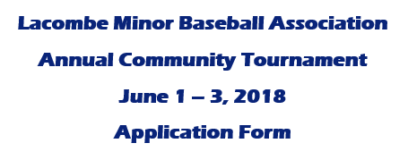

Division: circle appropriate division
Mosquito Community A $300
Pee Wee Community A $325
Bantam Community A $350
Midget Community A $375

Team Name: _____________________________________________________
Association Represented: ___________________________________________
Baseball Alberta League (eg. CABL): __________________________________
Team Contact: ____________________________________________________
Primary Phone #: __________________________________________________
Secondary Phone #: ________________________________________________
Email Address: ____________________________________________________
Registration Fee Cheque amount: _____________________________________
*all teams and subsequent roster players must be enrolled in ‘A’ level community Baseball. Roster verification from your organization or league may be required.

Please make all cheques payable to LMBA. Upon confirmation of team acceptance, the registration amount must be received by May 10th.

Forms can be mailed or emailed to:
LMBA Tournament Co-ordinator
Lacombe Minor Baseball Association
Box 5201
Lacombe, AB
T4L 1W9
Or
jcdunlap@telus.net

