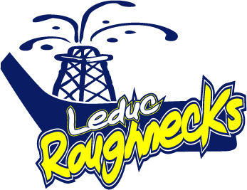
________________ 20__

Subject: Leduc Minor Hockey Team Donation Request
Dear ________________________,

The 2017-2018 Minor Hockey Season has begun and I would like to take this opportunity to call upon your generosity and support to become a donor to the Leduc Roughnecks ___________________ hockey team.
This team consists of young hockey players who are excited at the prospect of playing Canada’s great sport. In addition to countless hours of practice ice, they will be playing over 18 regular season games and they hope to participate in several tournaments where they can test their skills against other teams outside of our own area. Your donation will be used for_____________________________________________________________________

For donations for the purchase of team wear your company name may be attached to the product. The team appreciates your commitment to youth recreational activities within our community. Your donation is crucial to ensuring young hockey players in our community have the opportunity to continue to develop their skills and play the sport of hockey.

If you would like to support the 2017/2018 Leduc Roughnecks __________________ hockey team, please complete the attached form and return it along with a cheque or item to us as at your earliest convenience. Should you have any questions regarding this request, please do not hesitate to call ___________________________ at ________________________.
Or for sponsorship details regarding the entire Leduc Minor Hockey Organization contact fundraising@lmha.ab.ca
Regards,
Manager, Leduc Roughnecks __________________

2017/2018 Leduc Roughnecks Team Sponsorship Form

Business Name: ________________________________________________________
Team being supported: __________________________________________________
Address: ______________________________________________________________
Contact: ______________________________________________________________
Telephone: ________________________ Email: ______________________________
Amount/Item: _________________________

Cheque should be made payable to Leduc Roughnecks ________________ and can be sent to:

______________________________________________________________________

