Travel Permit Procedures
Travel permits are applied for online at www.lloydminsterminorhockey.com and MUST BE applied for 7 days prior to travel date.
Under LMHA forms – Travel permits
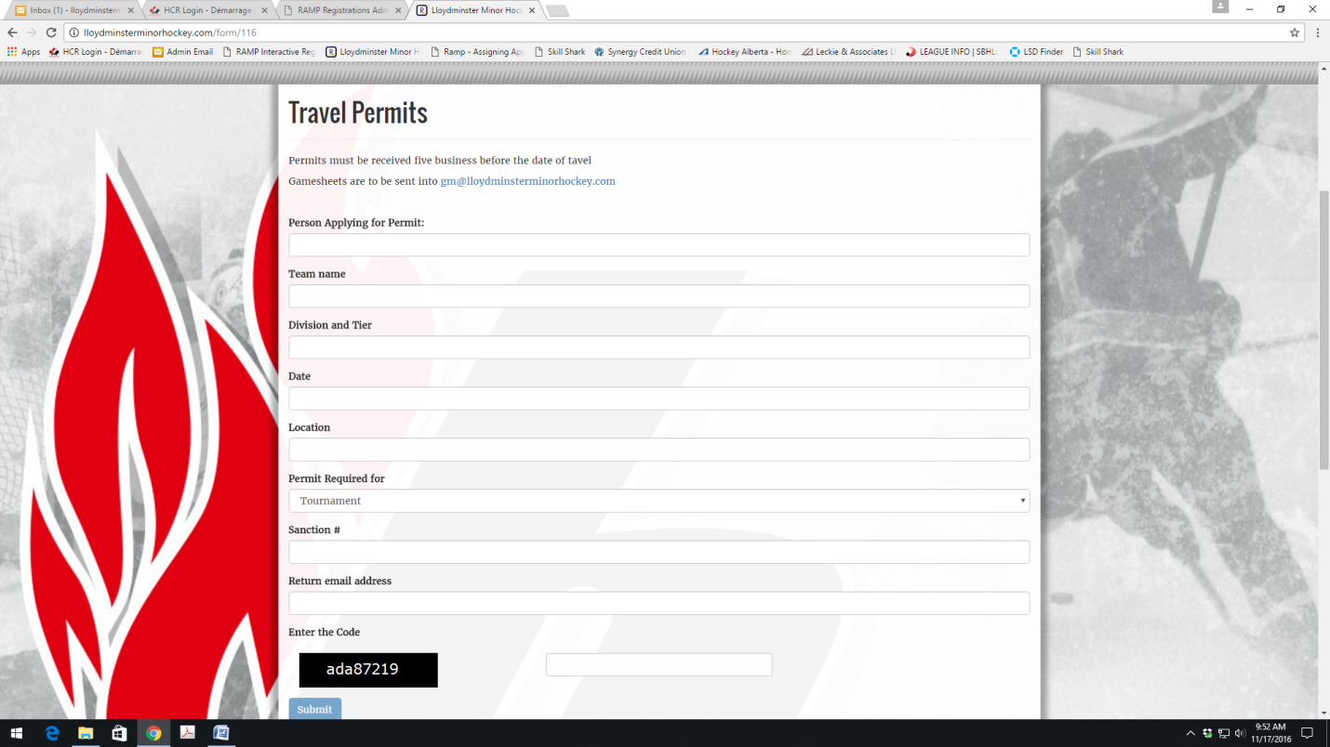

Travel Permits are required for the following:
- All tournaments
- All Exhibition games
Game sheets and any write ups must be submitted to the following if playing with a travel permit:
LMHA office
- gm@lloydminsterminorhockey.com
- 780-875-4426 (fax)
Hockey Alberta Discipline/Sanctioning Coordinator
- HA information will be listed on your approved travel permit on where to send the required information to.

