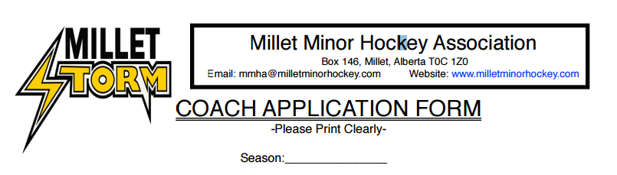

Full Legal Name:_____________________________________ Date of Birth: _____/_____/_____ (MM/DD/YY)
Mailing Address:__________________________ City/Town: ________________ Postal Code: ____________
Street Address/Legal Land Description must also be provided: ______________________________________
Home Phone: ____________________Cell: ______________________Email: _________________________

Coaching Position you are applying for:
Head Coach: _______ Assistant Coach: _______ Trainer: _______

Check ALL Current Coach Certification:
None - require coaching clinics: _______ Intro to Coach: _______ Coach Level I: _______ Coach Level II or III: _______ Respect in Sport (Speak Out): _______ Hockey Canada Safety Program: _______

Hockey Level Applying for:
Pre Novice: _______ Novice: _______ Atom: _______ Peewee: _______ Bantam: _______ Midget: _______

Coaching Experience: _________________________________________________________________________________________ _________________________________________________________________________________________ _________________________________________________________________________________________ _________________________________________________________________________________________ _________________________________________________________________________________________

Please list TWO references who can verify your coaching/hockey experience:
Name: ______________________________ Phone Number: _________________________

Name: ______________________________ Phone Number: _________________________

____________________________________________ ___________________________
Signature Date

*All coaches will be asked to complete a Criminal Record and Vulnerable Section Record Checks with the RCMP. MMHA will not accept Head Coach applications without the required certification for the level you are applying. Deadline for all coaching applications is August 15. Please submit this form to vp@milletminorhockey.com

