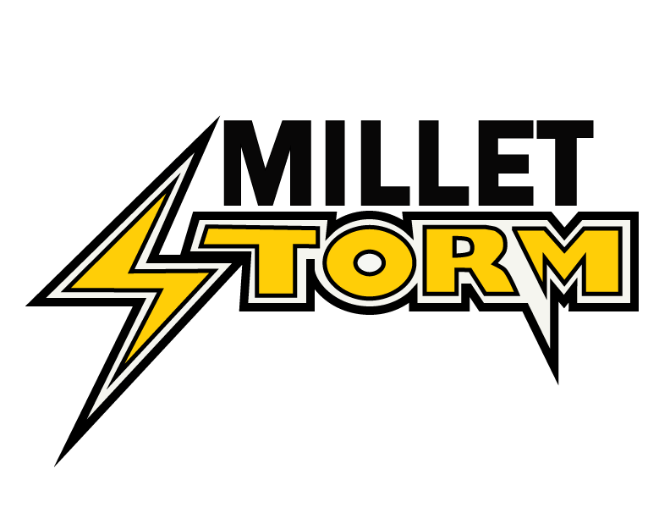 MMHA - INCIDENT REPORT FORM

This form is to be utilized to report an incident of inappropriate behavior. An individual(s) displaying inappropriate behavior are verbally or physically harassing, abusing, or bullying a member(s) of MMHA.

DATE & TIME OF INCIDENT: _____________________________________________

NAME OF OFFENDING MEMBER: ________________________________________

ASSOCIATED TEAM: ____________________________________________________

NAMES OF WITNESSES: _________________________________________________

DESCRIPTION OF INCIDENT: ____________________________________________

(please use the back of this form if more space is required – or type on a separate sheet)

YOUR EXPECTED OUTCOME FROM THE INCIDENT: _______________________

Please print clearly, be direct and to the point. Reports that are not legible will not be accepted. The report will go through the motions laid out in the Inappropriate Conduct Protocol. You can expect results from the Discipline Committee in 2-4 weeks.

FORM SUBMITTED BY: _____________________________ DATE: ______________

ADDRESS: _____________________________________________________________

PHONE: _______________________ EMAIL: _______________________________

SIGNATURE: ___________________________________________________________

