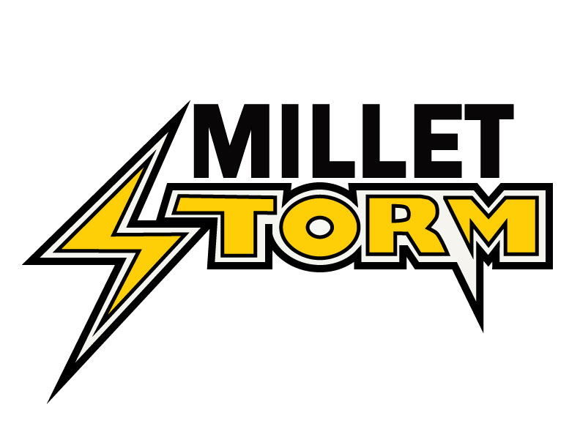
MILLET MINOR HOCKEY ASSOCIATION
Box 146, Millet, AB, T0C 1Z0

September 2018

Royal Canadian Mounted Police
Protective Services Building
5005 48th Avenue OR #1 - 4119 50th Street
Wetaskiwin, Alberta, T9A 0N1 Leduc, Alberta, T9E 7L9

To Whom It May Concern:

This letter is to confirm that _____________________________________ has applied for a volunteer position with Millet Minor Hockey. All coaches, managers and board members with Millet Minor Hockey require Vulnerable Sector and Criminal Records Check to be completed once every three years.

Thank you in advance for your continued support in offering these checks as a complimentary service.

Sincerely,

Greg Lepage
President, Millet Minor Hockey Association

