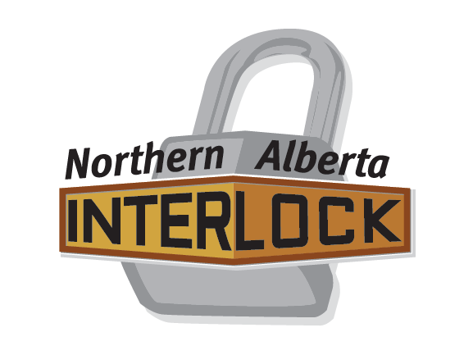NOTICE OF MOTION FORM

Submission by a Member Association in Good Standing

I / We: (name of Association and member representing the association)

Email:

Phone:

Submit the following Notice of Motion:
(to be dealt with at the Annual General Meeting of the Northern Alberta Interlock to be held on the 5th of May 2018 in Stony Plain, Alberta)

Motion:

Purpose of Motion:

Mover’s Name:

Seconder’s Name:

This form must be submitted by the 14th of April 2018 to Executive@nainterlock.com

