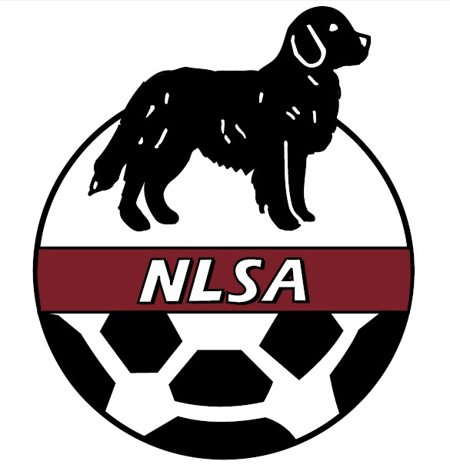
NEWFOUNDLAND AND LABRADOR SOCCER ASSOCIATION
39 Churchill Avenue, St. John’s NL A1A 0H7
Phone: (709) 576-0601 Fax: (709) 576-0588 Email: rob@nlsa.ca

PERMISSION TO TRAVEL- REQUEST FORM

Name of Club/ Association: ______________

Contact Name: ____________ Phone: ______________

Fax: _________________________ Email: ___________________

Mailing Address:

City: ________________ Province: _____Postal Code: __________________

Signature of Club/ Association representative: _________________________________

PLEASE ENCLOSE TEAM ROSTER AND COACHING STAFF NAMES ON SEPARATE FORMS

Tournament Attending: _________________________________

Date:____________ To: __________ Age: _____Host Affiliation: ________

City: _______ Prov. _____________Country: _____________

Email Address: _____________________Mode of Travel: _________________

Accommodations: ____________ Estimated Cost of Trip: _______________

______________________________________________________________________

OFFICE USE ONLY

Date Approved: __________________Team Roster Approved: ______________

International Fee Paid ($150.00): ______________ or;

Inter-Provincial Fee Paid ($50.00) _________

NLSA Representative: ____________________________

