Please PHOTO COPY blank form as required.

North Central
Minor Hockey Association

ANNUAL GENERAL DIRECTORS MEETING

NOTICE OF MOTION

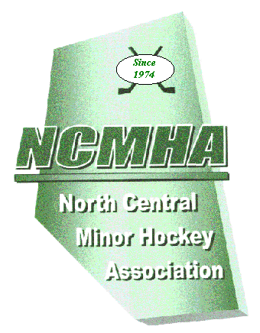
Executive use

Motion # ______

AMENDMENT TO (describe) :

SECTION 1 OBJECT / BY-LAW #: page #:

SECTION 2 REGULATION #: page #:

SUBMITTED BY: (Association)

AUTHORIZED SIGNATURE:

CURRENT WORDING:

PROPOSED WORDING:

RATIONALE FOR CHANGE:

Attach extra sheets as required.

