Please PHOTO COPY blank form as required.
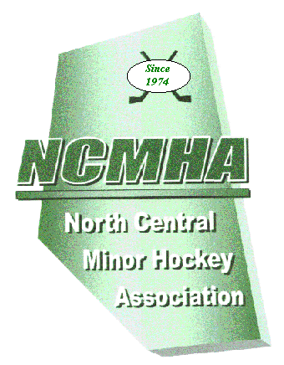
North Central
Minor Hockey Association

PLAYOFF AGREEMENT FORM

NCMHA.com

Divison: Atom Peewee Bantam Midget Female

Tier: 1 2 3 4 5

Series: ____________

Format: Best of 1 Two Game Total Points Best of 3 Best of 5

Team with Venue: __________________________ Team without Venue: _________________________

GAME 1
Date: _________________________ Time: ___________ Location: _________________________

GAME 2
Date: _________________________ Time: ___________ Location: _________________________

GAME 3
Date: _________________________ Time: ___________ Location: _________________________

GAME 4
Date: _________________________ Time: ___________ Location: _________________________

GAME 5
Date: _________________________ Time: ___________ Location: _________________________

Team With Venue Manager

(print)_________________________________________

(sign) _________________________________________

(date) _________________________________________
Team Without Venue Manager

(print)_________________________________________

(sign) _________________________________________

(date) _________________________________________

GOVERNOR’S SECTION Approved Not Approved Notified both teams

(sign) _____________________________________ (date) ____________________

Reasons for not approving ___________________________________________________ _____________________________________________________________________
_____________________________________________________________________

