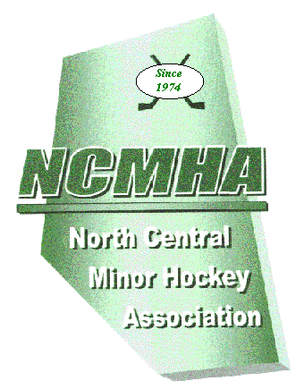
North Central
Minor Hockey Association

TEAM CANCELLATION NOTICE

NCMHA.com

TO Ellen Bonde, NCMHA Treasurer DATE____________________________________
R. R. 3
Rocky Mountain House, AB
T4T 2A3 MHA _____________________________________
Ph/Fax 403-845-6894
niels_ellen@telusplanet.net
REP Signature ______________________________

Our association has cancelled the following team(s) from the NCMHA after the registration fees were paid. Please refund the fees minus the cost of a scorebook for each team.

Team______________________________ fees 250.00 - 20.00 = $230.00

Team______________________________ fees___________ = _______

Team______________________________ fees___________ = _______

Total _______

Please mail cheque to: _______________________________________

____________________________________________________

____________________________________________________

____________________________________________________

