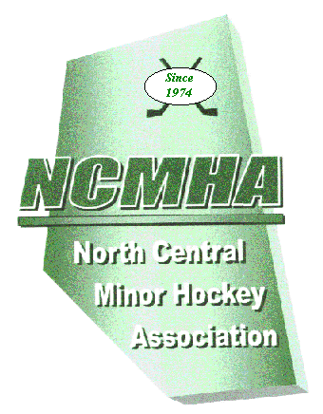 Registration
Please have prepared forSeptember General Meeting!
North Central
Minor Hockey Association

REGISTRATION
2015 - 2016 Season

NCMHA.com
2016-2017 Season

ASSOCIATION NAME _____________________________________________________
NCMHA REPRESENTATIVE ________________________ PHONE__________________
ASSOCIATION ADDRESS____________________________________________________
CITY / TOWN _________________________ POSTAL CODE ______________
TEAMS REGISTERING Minor + Female How many arenas? _________

ATOM number of teams ____ + _____ X $250.00 = $_______ total
PEEWEE number of teams ____ +_____ X $250.00 = $_______ total

BANTAM number of teams ____ + _____ X $250.00 = $_______ total

MIDGET number of teams ____ + _____ X $250.00 = $_______ total

Total teams ___+___ Total fees = $_______

One scorebook FREE per team
Extra Game Scorebooks no. _________ X $20.00 = $_______ total
One referee book FREE per arena
Extra Referee Report Books no. _________ X $20.00 = $_______ total
GRAND TOTAL = $___________

CHEQUE # _________

NAME ON CHEQUE ______________________________

- Associations are responsible for notifying the secretary and paying the treasurer for any teams registered after the fall general meeting.
- Requests for refunds must be made using a Team Cancellation Form.
- Refunds will only be issued if a Team Cancellation Form is received by April 30th of the current season.

Signed by _______________________________________________ Date ________________

