Coaches Guide to Web Site
- Login to your NW Team site
- Email Your team
- Score a game

Section 1: Login to your NW Team Site
Step 1: Go to NW web site
  - http://www.northwestbasketball.ca/
  - ON top of page click on “ADMIN LOGIN”
  - 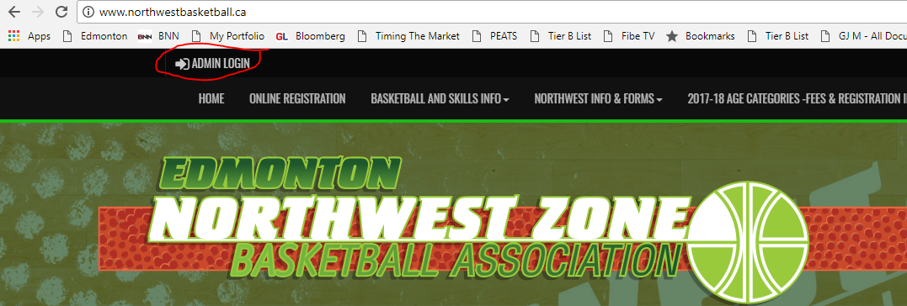
  - Enter your username and password.

Section 2: Email your team

Step 1: ON the left hand side click on MAIL ICON
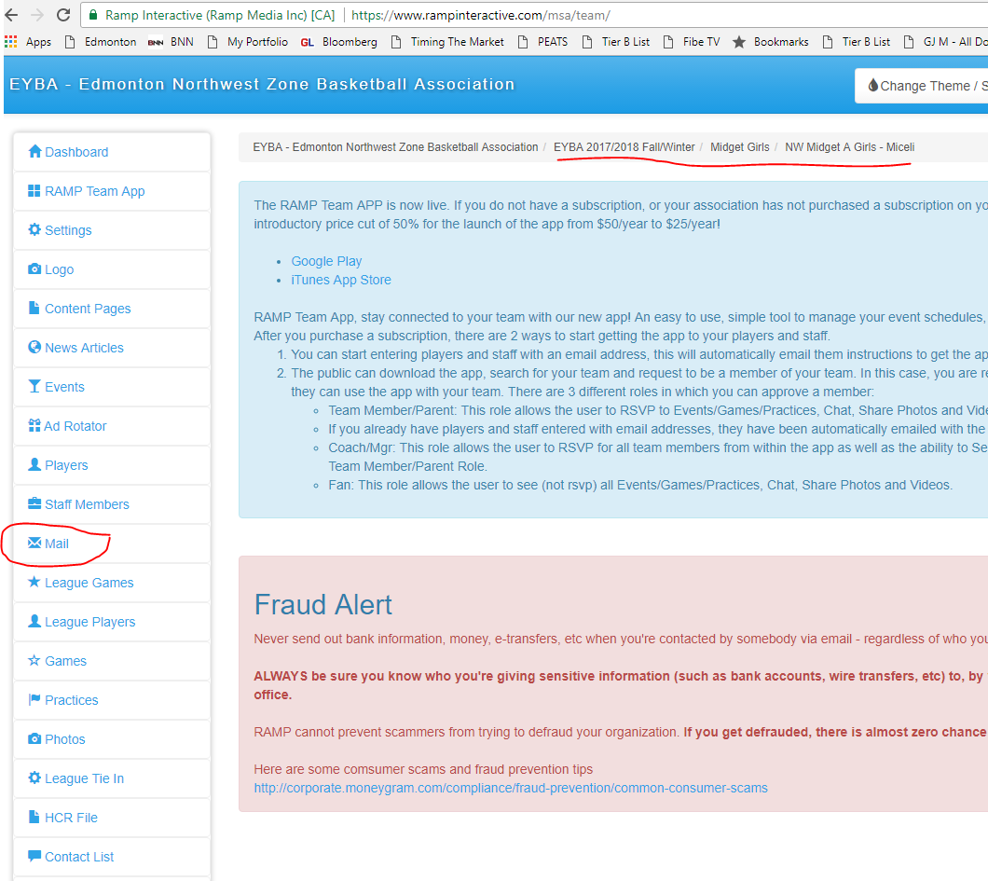
Step 2: Compose Email
Step 3: Click send
Section 3: Score a game
Step1: Click on “League Games ICON
Step 2:Click on “Game Sheet”
Step 3: Enter score
Step 4: Hit submit
If the Game was scored by other team
Step 1: Click on Verify
Step 2: Change Verification status to verified.
Step 3 Submit, at the bottom of page.
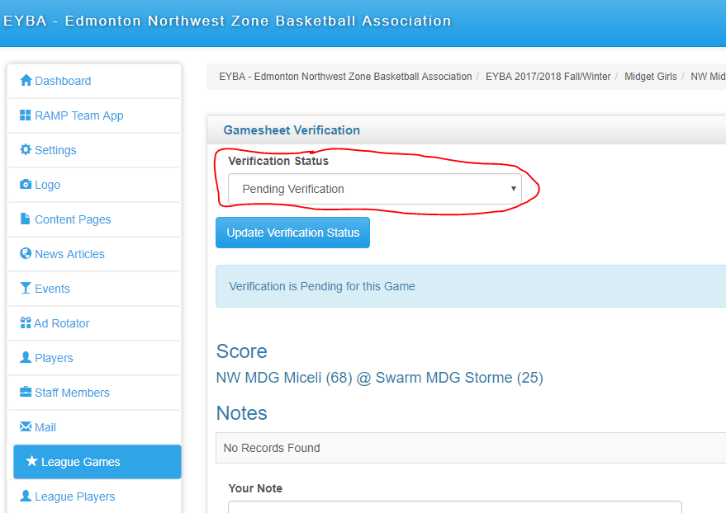

Section 4: Practices
Step 1: Click on Practices ICON on the left side
Step 2: Click on “Add Practice” Button
Step 3: Enter date, times and court.
Step 4: If recurring click button and enter the day of the week and the end date
Step 5: click on Submit.
*Note: You can email on submit for a single practice, but not a recurring practice. I have no idea why.

