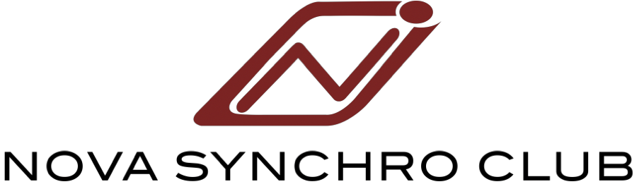

Wardrobe Form
Swimmer’s Name: ___________________________________________________________
Phone Number: ____________________ (daytime)_____________________(evening)
Parent’s Name: _____________________________________________________________
Coach’s Name: _____________________________ Team _________________________
ITEM | PRICE  (GST incl.) | QUANTITY | SIZE | COST
MANDATROY: Red Nova T-Shirt  Child Ivivva sizes 6-14 (Fly Tech SS Tee)  Adult Lululemon Sizes 2-12 (Swiftly Tech SS Crew) | Child-$38.00  Adult-$54.00
MANDATORY: Nova Club Swim Suit  Reversible to Black Figure Suit Sizes 22-48 | $87.00
MANDATROY: Black Nova Zip Jacket  Child Ivivva sizes 6-14 (Perfect You Practice Jacket)  Adult Lululemon sizes 2-12 (Define Jacket) | Child- $65.00  Adult - $96.00
MANDATORY: Nova Club Red Silicone Swim Cap | $10.00
MANDATORY: White Silicone Cap | $8.00
Nose clips Regular and Small | $5.00
Speedo Backpack Red(Optional) | $76.00
Swim Parka Black (Optional) | $109.00
Black Leggings  Child Ivivva (Rhythmic Tights)  Adult Lululemon (Wonder Under HR Tights) | Child- $40.00  Adult- $65.00
Black Shorts  Child Ivivva (Speedy Shorts)  Adult Lululemon (Runtimes Short II 4”) | Child - $34.00  Adult - $40.00
Red Nova Pullover Hoodie (Optional)  Child Sizes S-XL  Adult Sizes S-XL | $35.00

TOTAL: $ _______________
Payment: Please attach cheque payable to Nova Synchro Club with your order form (NO CASH).
Questions? Contact Trisha at 780-432-6596 or wardrobe@novasynchro.org
* T-shirts, zipjackets, leggings, and shorts are from Ivivva and Lululemon. Please know what size your child wears as there are no returns once they are ordered. You can go into the Ivivva store and Lululemon store in West Edmonton Mall to try on sizes if you are not sure.
**I will have a swimsuit sizing kit available to fit the athletes on Monday, September 10th, Tuesday, September 11th and Thursday, September 13th. I will be available each of those nights staring at 5:30 at the pools. Monday and Thursday I will be at Kinsmen pool on deck outside of the changerooms. Tuesday I will be at Terwilligar Rec Centre just outside of the stretch room. If your child will need a swim suit please make sure to come to one of those nights and I will assist you with sizing. If you cannot make it to one of these nights and your child does require a suit please contact me so I can arrange a time to meet. I will only have the swimsuit sizing kit for this one week.
All MANDATORY ITEMS PURCHASED THROUGH CLUB: Nova Swim Cap, Nova Club Suit (reversible for Black Figure Suit), Club T-shirt, and Club Zip Jacket.
GENERAL MANDATORY ITEMS: White swim cap and nose clips are required, they can be purchased anywhere or through the Club. Black shorts and black yoga pants are required and can be purchased through the club or separately.
NOTE: Caps and nose plugs can be purchased throughout the year. It is best to purchase a few nose clips and a couple caps as these often get lost.

